**PROJECT ON:**

# VIVEKANANDA ENGINEERING COLLEGE

**NIELIT – ‘O’ LEVEL**

**SUBMITED BY:-**



|  |  |  |
| --- | --- | --- |
| NAME | : | SURAJIT MONDAL |
| REGISTRATION NUMBER | : | 1000 |
| COURSE | : | NIELIT- ‘O’ LEVEL |
| START DATE | : |  |
| STUDY CENTRE | : | NIELIT (J.U. CAMPUS, KOLKATA) |
| SESSION | : | 2023 – 2024 |

**VIVEKANANDA ENGINEERING COLLEGE:**

***ACKNOWLEDGEMENT:***

I here by express my heartiest thanks to all sources who have contributed to the making this project. I obliged thanks to all those who have supported, provided their valuable guidance and helped me for the accomplishment of this project. I also express my hearty thanks to my family, friends and my teachers and all the well wishers.

I also would like to thanks my project guide Mr.-------------------------- for his guidance and timely suggestion and the information provided by him on this particular topic.

Above all its sincere thanks to the **NIELIT** for which this project is given consideration and was done with outmost seriousness.

**VIVEKANANDA ENGINEERING COLLEGE:**

**Contents:**

|  |  |  |
| --- | --- | --- |
| Introduction | : |  |
| System Configuration | : |  |
| Screen Shorts | : |  |
| Source Code | : |  |
| Bibliography | : |  |

**VIVEKANANDA ENGINEERING COLLEGE:**

**Introduction:**

The Vivekananda Engineering College in on of the best college in West Bengal. It’s located in Kolkata. The ranking of this college is 12th position in India. This college is so popular because after complete an engineering course most of the student got job from multinational companies, like Google, LNT, TCS, Wipro, Microsoft and more. The environment of this college is very good that’s why maximum students ware like do engineering course for this college. The Vivekananda college is stabiles in 1999 by Bidhan Chandra Ray. This provides most facility for the students so they can study well and build a stable student.

This college provides 4 engineering course which choose by the student for their ceria growth so they can got job from many companies. The main course of this college are 1.Computer Science and Engineering 2.Electrical Engineering 3.Artificial Engineering 4.Civil Engineering All this course have some duration to complete with in a period of time and the course free are difference. In below we mention the course duration and fee –

1. Computer Science and Engineering: This Computer Science and Engineering course you can complete with in duration of 4 year, and the course fee is only Rs. 4,70,000.
2. Electrical Engineering: This Electrical Engineering course you can complete with in duration of 4 year, and the course fee is only Rs. 3,00,000.
3. Artificial Engineering: This Artificial Engineering course you can complete with in duration of 4 year, and the course fee is only Rs. 4,52,000.
4. Civil Engineering: This Civil Engineering course you can complete with in duration of 3 year, and the course fee is only Rs. 2,30,000.

All above course and their details available in the web side which are mention below. Wehe you can check details and about the course.

We have mentioned also the college are inside the web side you can check Class Rooms, Seminar Rooms, Library Room and Auditorium Rooms. You can check and explore the photos which is mention in the web side. All are real images of this college.

**VIVEKANANDA ENGINEERING COLLEGE:**

**SYSTEM CONFIGURATION**

|  |  |
| --- | --- |
| **Hard ware Requirements:** | |
| Processor | Intel Core i3 2.2GHz |
| RAM | DDR3 4GB RAM |
| Disk Space | 100MB |

|  |  |
| --- | --- |
| **Soft ware Requirements:** | |
| Operating System | Windows XP, Vista, 7,8,10,11 |
| Browser | IE, Goole Chrome, Firefox |

**VIVEKANANDA ENGINEERING COLLEGE:**

**SCREEN SHOTS**

Below Provide Screen sorts of the Web side. It’s showcasing the pages like -

Home Page (with menu bar, sort information of courses, college area, other information, Address, contact details),

About Page (about college, about course),

Registration (Registration form),

Admission (Admission form)

Log In (Login page),

Notice Page (New notice page, previous notice page)

**VIVEKANANDA ENGINEERING COLLEGE:**

**Home page**

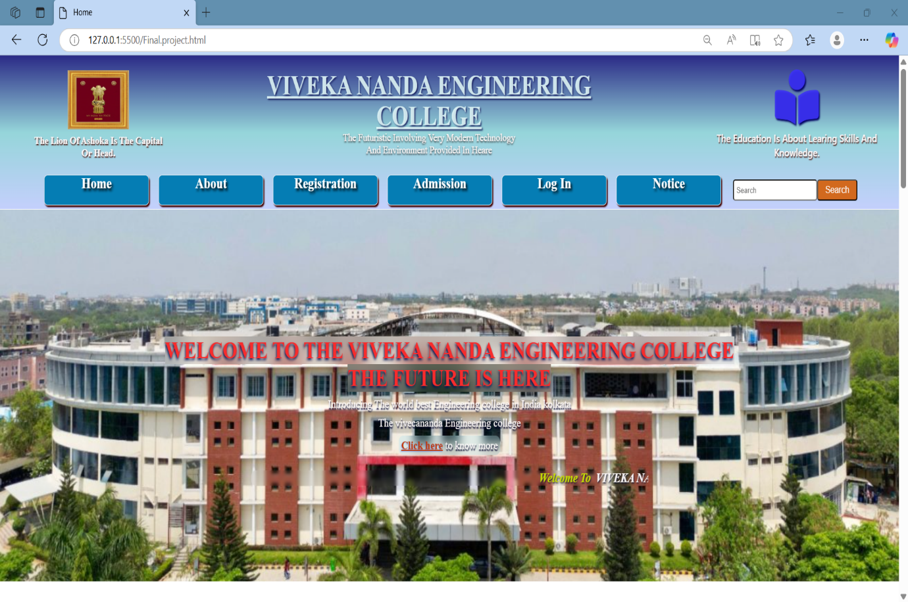

**VIVEKANANDA ENGINEERING COLLEGE:**

**Home page**

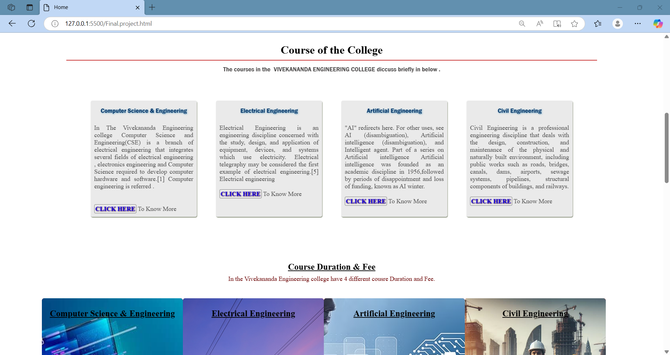

**VIVEKANANDA ENGINEERING COLLEGE:**

**Home page**

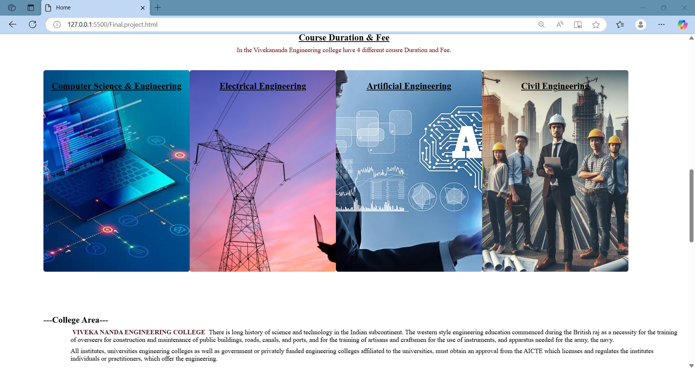

**VIVEKANANDA ENGINEERING COLLEGE:**

**Home page**

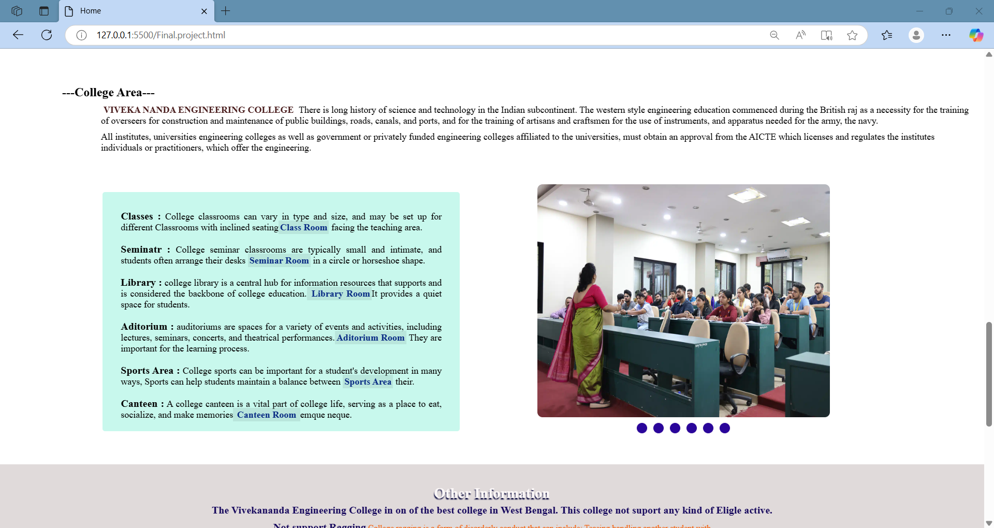

**VIVEKANANDA ENGINEERING COLLEGE:**

**Home page**

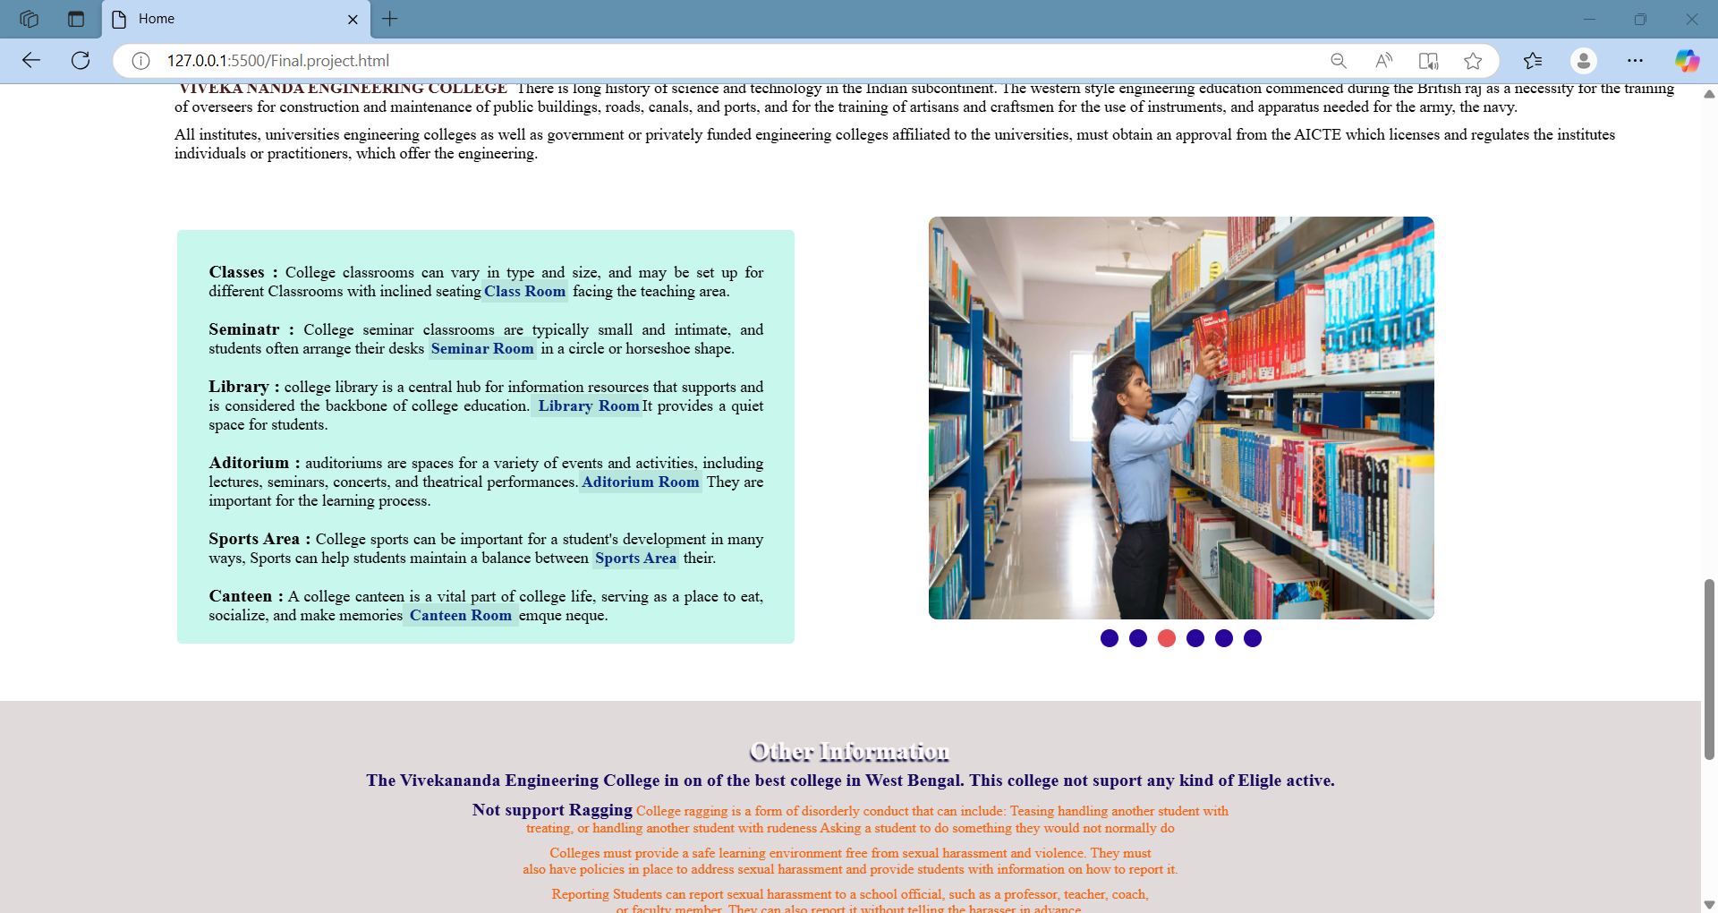

**VIVEKANANDA ENGINEERING COLLEGE:**

**Home page**

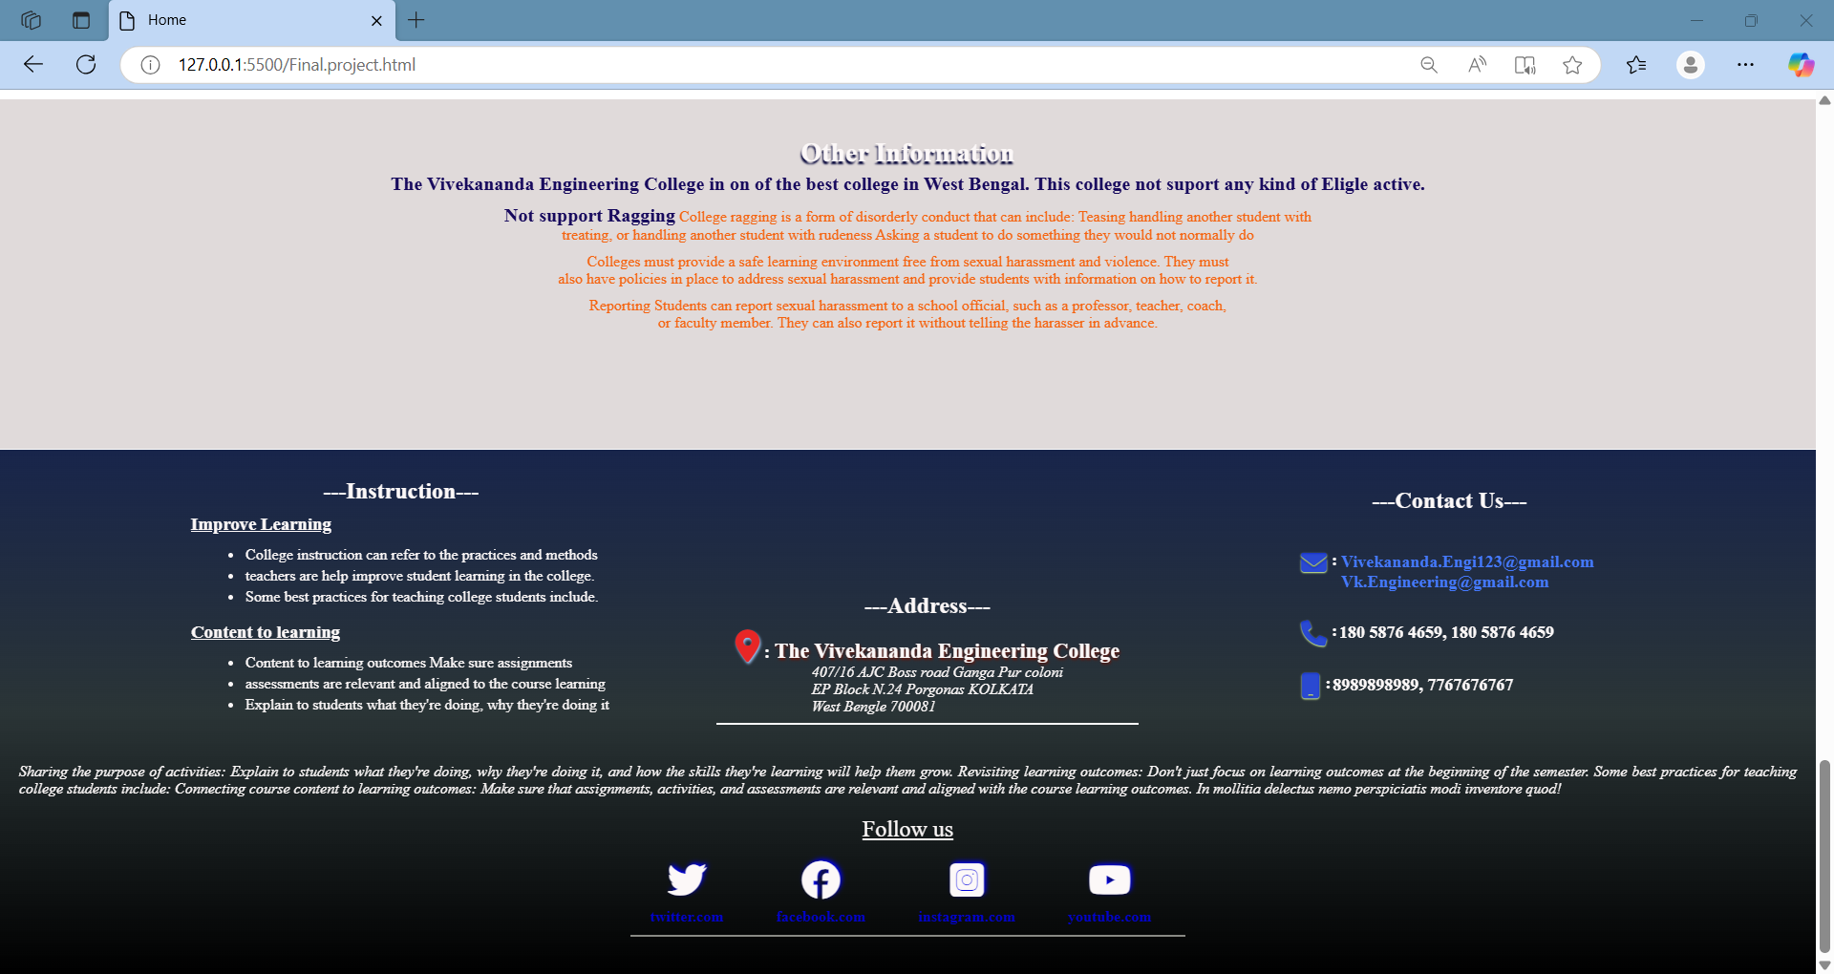

**VIVEKANANDA ENGINEERING COLLEGE:**

**About College**

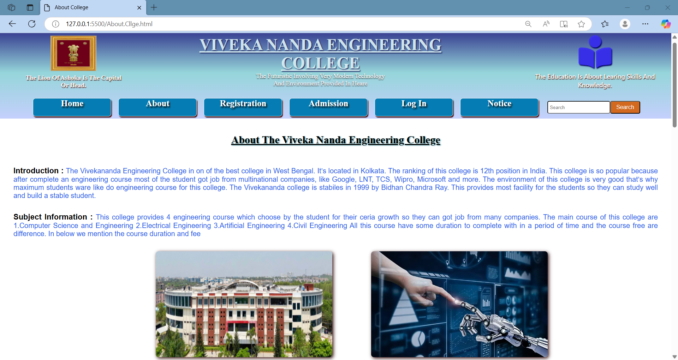

**VIVEKANANDA ENGINEERING COLLEGE:**

**About College**

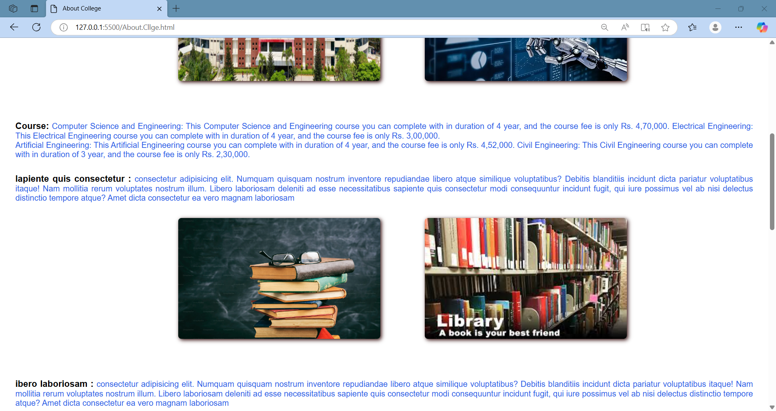

**VIVEKANANDA ENGINEERING COLLEGE:**

**About Course**

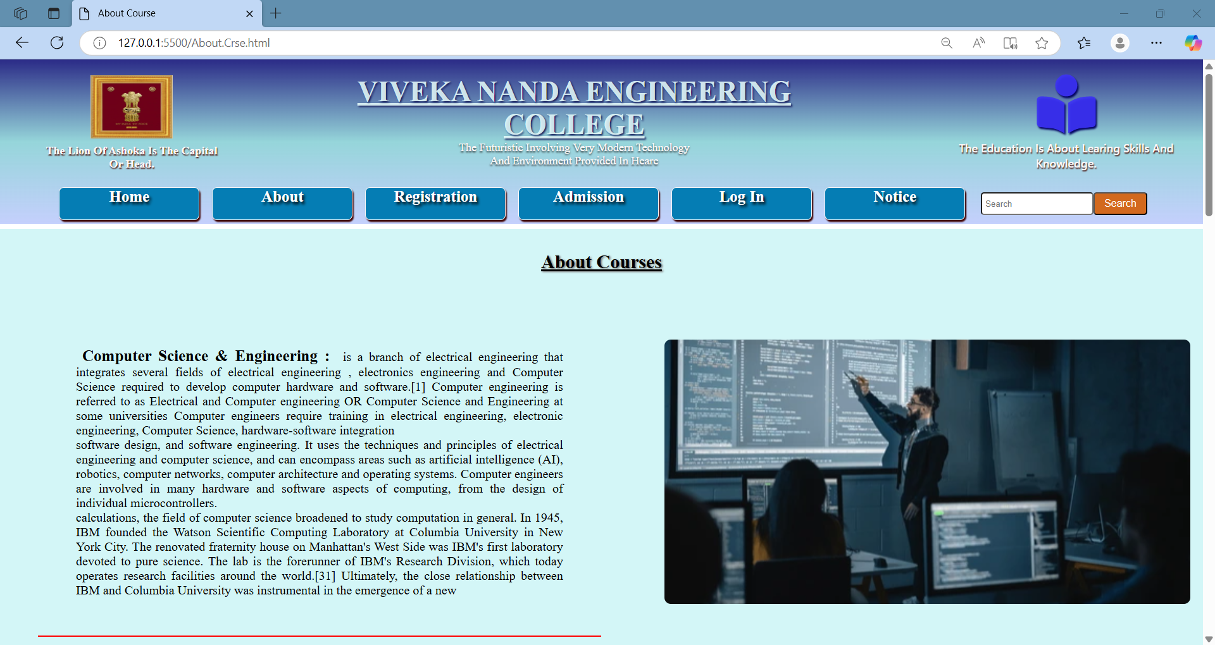

**VIVEKANANDA ENGINEERING COLLEGE:**

**About Course**

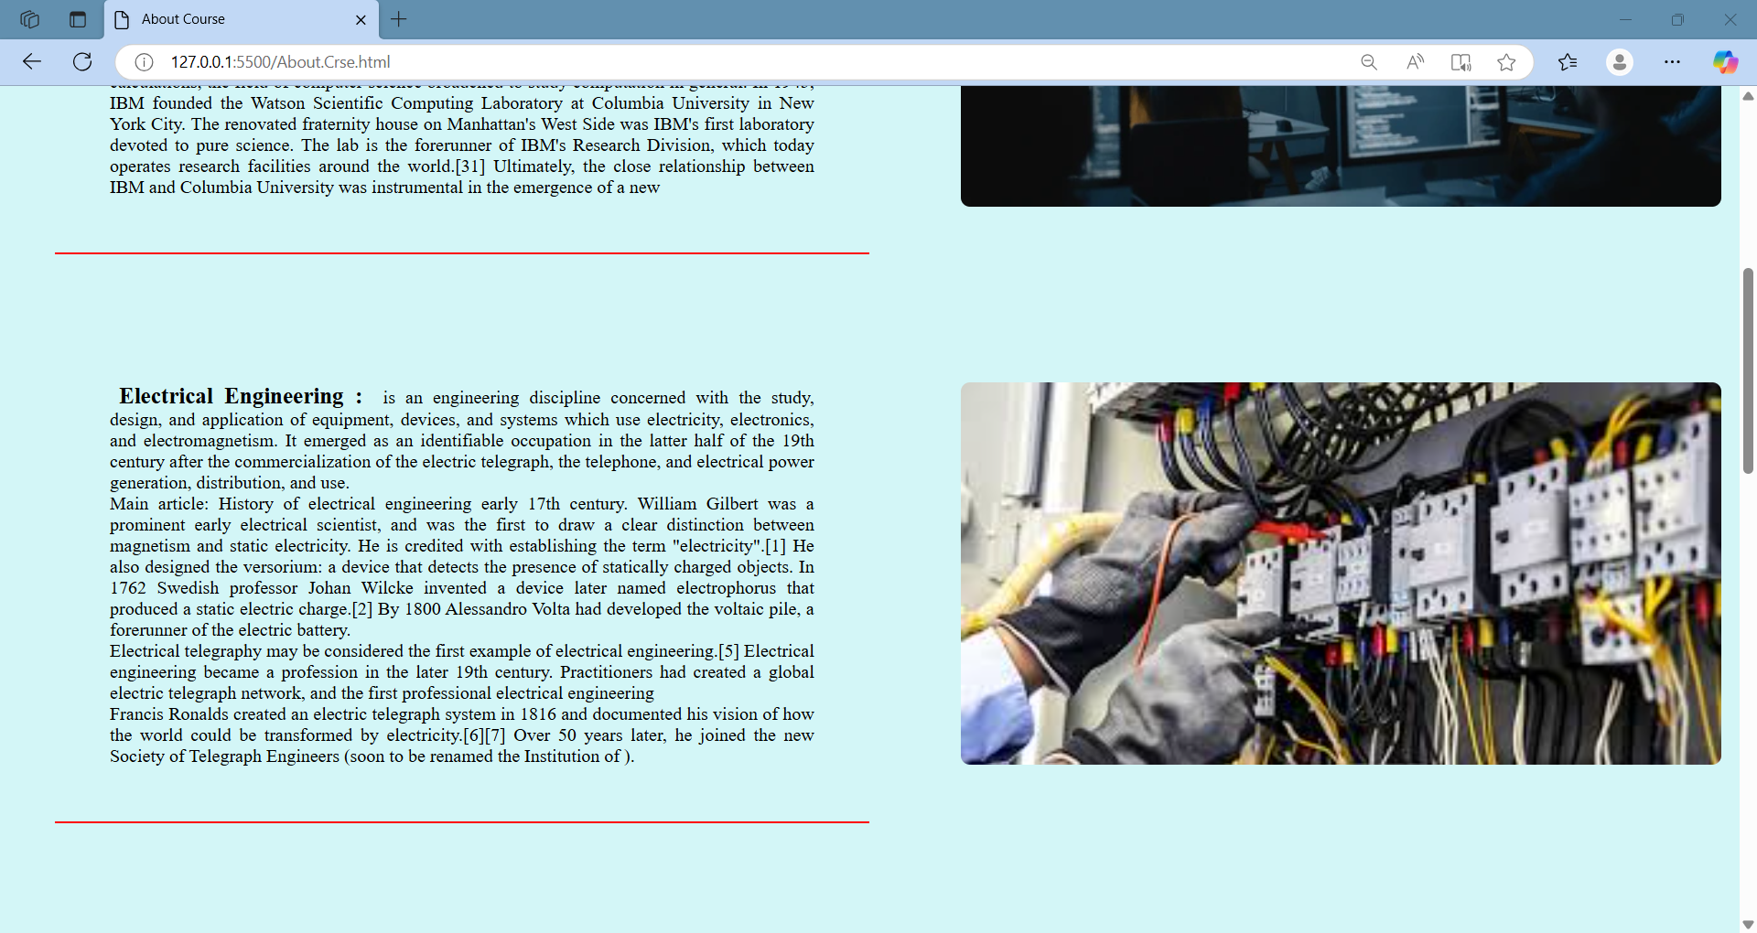

**VIVEKANANDA ENGINEERING COLLEGE:**

**About Course**

s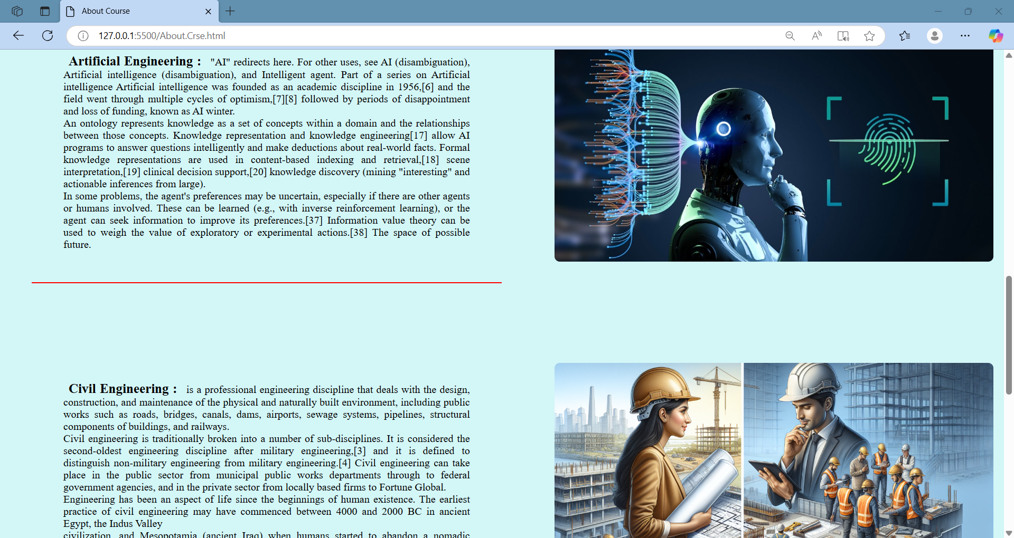

**VIVEKANANDA ENGINEERING COLLEGE:**

**Registration Form**

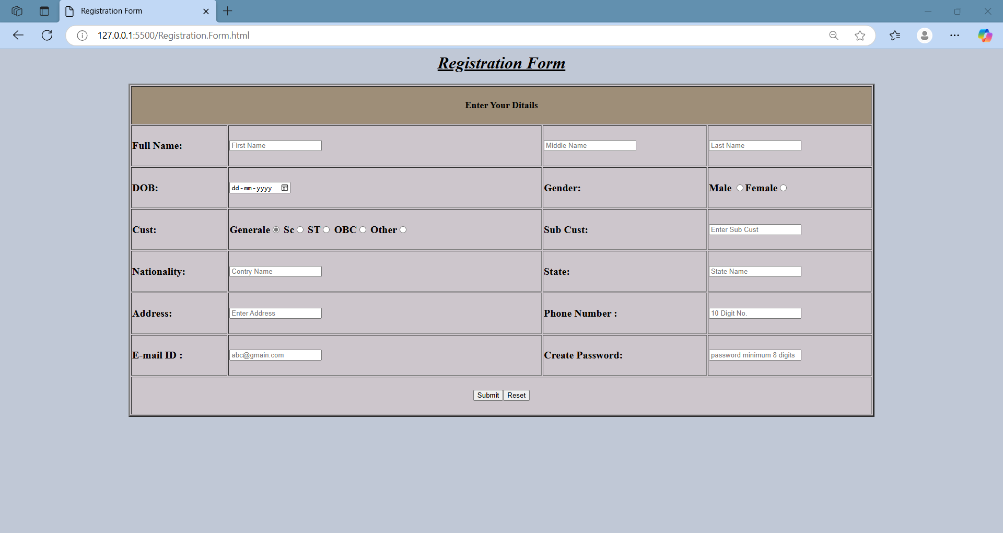

**VIVEKANANDA ENGINEERING COLLEGE:**

**Admission Form**

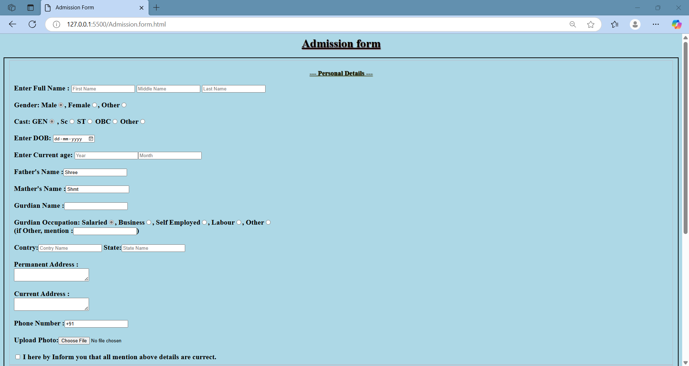

**VIVEKANANDA ENGINEERING COLLEGE:**

**Log In Form**

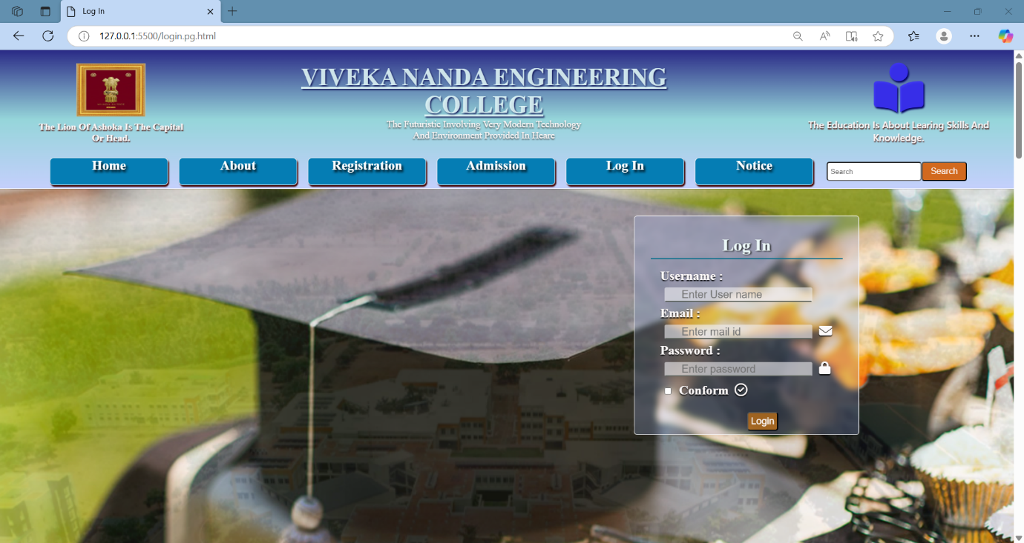

**VIVEKANANDA ENGINEERING COLLEGE:**

**New Notice**

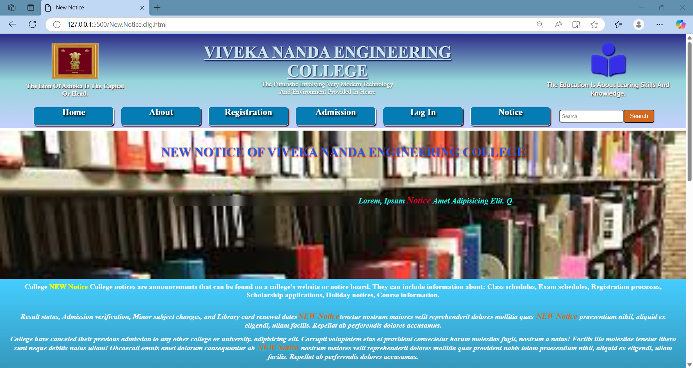

**VIVEKANANDA ENGINEERING COLLEGE:**

**New Notice**

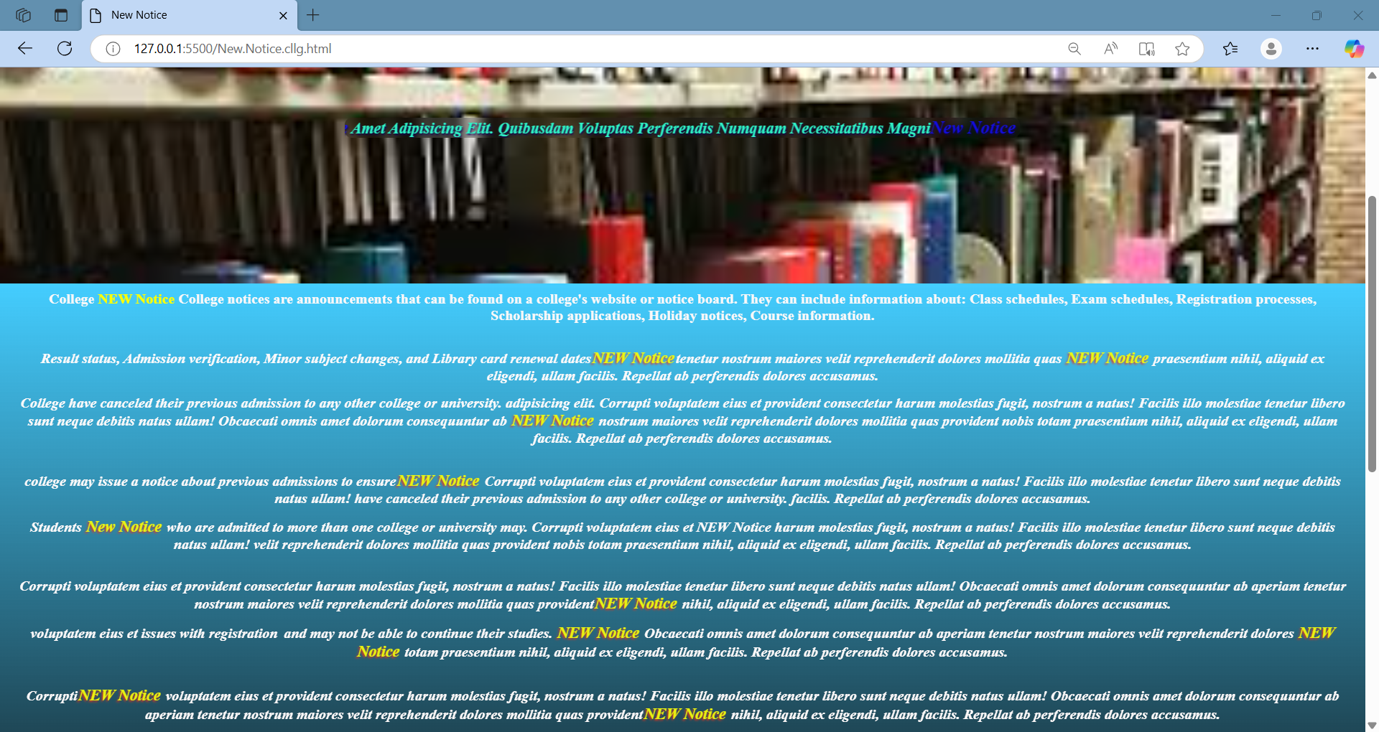

**VIVEKANANDA ENGINEERING COLLEGE:**

**Previous Notice**

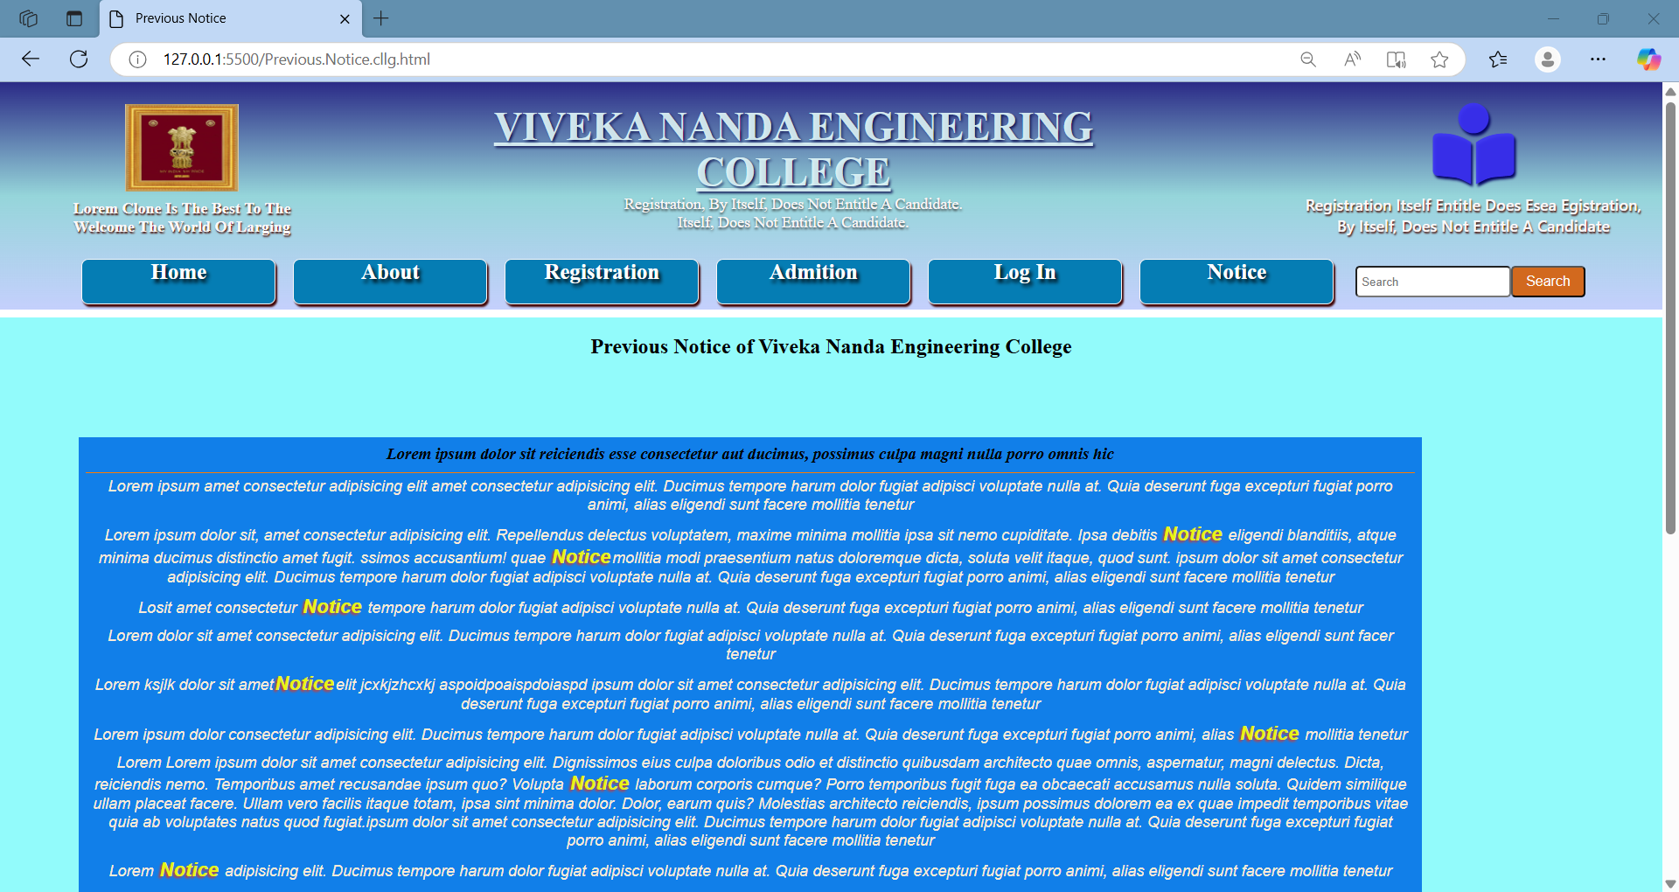

**VIVEKANANDA ENGINEERING COLLEGE:**

**Previous Notice**

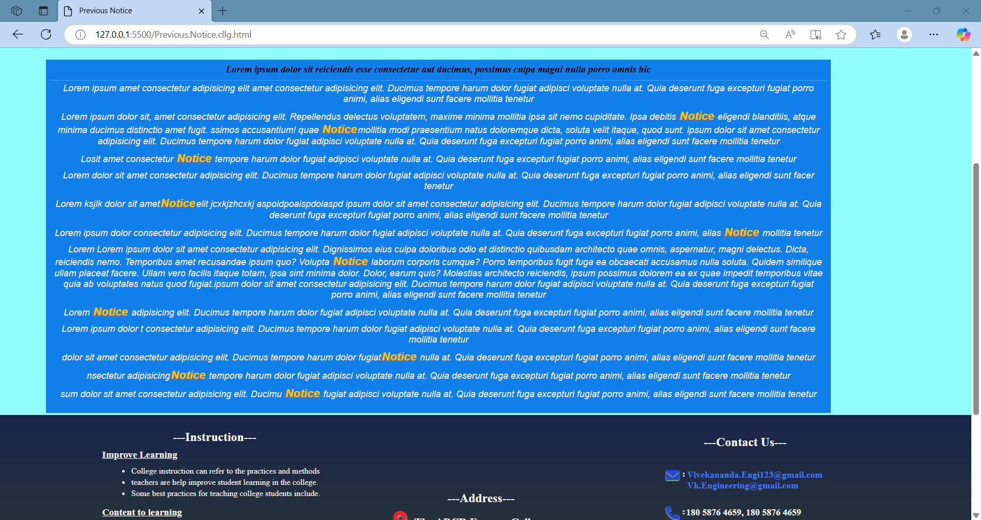

**VIVEKANANDA ENGINEERING COLLEGE:**

**Source Code**

Below is providing the **Source Code** of the project of Vivekananda Engineering College.html in briefly.

**VIVEKANANDA ENGINEERING COLLEGE:**

***Vivekananda Engineering College.html***

**<!DOCTYPE html>**

**<html>**

**<head>**

**<title>Vivekananda.Engineering.College.html</title>**

**<meta name="viewport" content="width=device-width, initial-scale=1">**

**<link rel="stylesheet" href="final.Css.Style.css">**

**<link rel="stylesheet" href="https://cdnjs.cloudflare.com/ajax/libs/font-awesome/6.6.0/css/all.min.css" integrity="sha512-Kc323vGBEqzTmouAECnVceyQqyqdsSiqLQISBL29aUW4U/M7pSPA/gEUZQqv1cwx4OnYxTxve5UMg5GT6L4JJg==" crossorigin="anonymous" referrerpolicy="no-referrer" />**

**</head>**

**<body>**

**<section>**

**<div class="top_head">**

**<div class="logo_left">**

**<span>**

**<img src="ashok.stamv.2.png">**

**<p class="text_1">The Lion of Ashoka is the capital or head. </p>**

**</span>**

**</div>**

**<div class="head_nam">**

**<h1>Viveka Nanda Engineering College</h1>**

**<p>The futuristic involving very modern technology</p>**

**<p>and environment provided in heare</p>**

**</div>**

**<div class="logo_right">**

**<span>**

**<i class="fa-duotone fa-solid fa-book-open-reader"></i>**

**VIVEKANANDA ENGINEERING COLLEGE:**

***Vivekananda Engineering College.html***

**<p>The Education is about learing skills and knowledge.</p>**

**</span>**

**</div>**

**</div>**

**<nav>**

**<div class="menu_bar" id="menu_link">**

**<span class="close_bar"> <i class="fa-solid fa-circle-xmark" onclick="close_menu"></i></span>**

**<ul>**

**<li class="active">**

**<a id="home" href="Final.project.html">Home</a>**

**</li>**

**<li><a href="#_block">About</a>**

**<div class="sub_menu1">**

**<ul>**

**<li>**

**<a href="About.Cllge.html">College</a>**

**</li>**

**<li>**

**<a href="About.Crse.html">Course</a>**

**</li>**

**</ul>**

**</div>**

**</li>**

**<li>**

**<a href="Registration.Form.html">Registration</a>**

**VIVEKANANDA ENGINEERING COLLEGE:**

***Vivekananda Engineering College.html***

**</li>**

**<li>**

**<a href="Admission.form.html">Admission</a>**

**</li>**

**<li>**

**<a href="login.pg.html" class="login_1">Log In</a>**

**</li>**

**<li><a href="#_block">Notice</a>**

**<div class="sub_menu1">**

**<ul>**

**<li><a href="New.Notice.cllg.html">New Notice</a></li>**

**<li><a href="Previous.Notice.cllg.html">Previous Notice</a></li>**

**</ul>**

**</div>**

**</li>**

**<input placeholder="Search" id="srch_txt">**

**<button id="srch">Search</button>**

**</ul>**

**</div>**

**<span class="open_bar"><i class="fa-solid fa-bars" onclick="open_menu"></i></span>**

**</nav>**

**</section>**

**<section class="body_img">**

**<div id="bck_img">**

**<div id="pg_1">**

**<h1>Welcome  To  the  Viveka Nanda Engineering College</h1>**

**<h1>The future is here</h1>**

**VIVEKANANDA ENGINEERING COLLEGE:**

***Vivekananda Engineering College.html***

**<p>Introducing The world best Engineering college in India kolkata</p>**

**<p>The vivecananda Engineering college</p>**

**<p class="Vw"><a href="About.Cllge.html" id="a_click">Click here</a> to know more</p>**

**<marquee class="moving">**

**Welcome to <strong> Viveka Nanda Engineering College </strong>the future is here, to be a Engineer in different field.**

**</marquee>**

**</div>**

**</div>**

**</section>**

**<div class="st1">**

**<section class="Course">**

**<h2> Course of the College</h2>**

**<h3>The courses in the <strong> Vivekananda Engineering College</strong>diccuss briefly in below .</h3>**

**<div class="all_course">**

**<div class="Course_nam">**

**<h3>Computer Science & Engineering</h3>**

**<p>In The Vivekananda Engineering college  Computer Science and Engineering(CSE)**

**is a branch of electrical engineering that integrates several fields of electrical engineering , electronics engineering and Computer Science required to develop computer hardware and software.[1] Computer engineering is referred .**

**</p>                                </p>**

**<p><a href="About.Crse.html">CLICK HERE</a> To Know More</p>**

**</div>**

**<div class="Course_nam">**

**<h3>Electrical Engineering</h3>**

**<p>Electrical Engineering is an engineering discipline concerned with the study, design, and application of equipment, devices, and systems which use electricity.**

**Electrical telegraphy may be considered the first example of electrical engineering.[5] Electrical engineering**

**</p>**

**<p><a href="About.Crse.html">CLICK HERE</a> To Know More</p>**

**</div>**

**<div class="Course_nam">**

**<h3>Artificial Engineering</h3>**

**<p>**

**"AI" redirects here. For other uses, see AI (disambiguation), Artificial intelligence (disambiguation), and Intelligent agent.**

**Part of a series on Artificial intelligence Artificial intelligence was founded as an academic discipline in 1956,followed by periods of disappointment and loss of funding, known as AI winter.**

**</p>**

**<p><a href="About.Crse.html">CLICK HERE</a> To Know More</p>**

**</div>**

**<div class="Course_nam">**

**<h3>Civil Engineering</h3>**

**<p>**

**Civil Engineering  is a professional engineering discipline that deals with the design, construction, and maintenance of the physical and naturally built environment, including public works such as roads, bridges, canals, dams, airports, sewage systems, pipelines, structural components of buildings, and railways.**

**</p>**

**<p><a href="About.Crse.html">CLICK HERE</a> To Know More</p>**

**</div>**

**</div>**

**</section>**

**<section class="Du_Fee">**

**<h2>Course Duration & Fee</h2>**

**<p>In the Vivekananda Engineering college have 4 different cousre Duration and Fee.</p>**

**<div class="Du_Fee_course">**

**<div class="c1">**

**<h2 class="img_1">Computer Science & Engineering**

**<br>**

**<i>Duration - 4 Year <br> Fee - Only 4,70,000 Rs</i></h2>**

**</div>**

**<div class="c1">**

**<h2 class="img_2">Electrical Engineering**

**<br>**

**<i>Duration - 4 Year <br> Fee - Only 3,00,000 Rs</i></h2>**

**</div>**

**<div class="c1">**

**<h2 class="img_3">Artificial Engineering**

**<br>**

**<i>Duration - 4 Year <br> Fee - Only 4,52,000 Rs</i></h2>**

**</div>**

**<div class="c1">**

**<h2 class="img_4">Civil Engineering**

**<br>**

**<i>Duration - 3 Year <br> Fee - Only 2,30,000 Rs</i></h2>**

**</div>**

**</div>**

**</section>**

**<div class="area">**

**<h2 class="heading">---College Area---</h2>**

**<p class="p1"> <strong> Viveka Nanda Engineering College </strong>**

**There is long history of science and technology in the Indian subcontinent. The western style engineering education commenced during the British raj as a necessity for the training of overseers for construction and maintenance of public buildings, roads, canals, and ports, and for the training of artisans and craftsmen for the use of instruments, and apparatus needed for the army, the navy.**

**</p>**

**<p class="p1">All institutes, universities engineering colleges as well as government or privately funded engineering colleges affiliated to the universities, must obtain an approval from the AICTE which licenses and regulates the institutes**

**individuals or practitioners, which offer the engineering.**

**</p>**

**<div class="vk_cllg">**

**<div class="para">**

**<p>**

**<strong>Classes :</strong>**

**College classrooms can vary in type and size, and may be set up for different**

**Classrooms with inclined seating<a href="#_block">Class Room</a> facing the teaching area.            </p>**

**<p>**

**<strong>Seminatr :</strong>**

**College seminar classrooms are typically small and intimate,**

**and students often arrange their desks <a href="#_block"> Seminar Room</a> in a circle or horseshoe shape.**

**</p>**

**<p>**

**<strong>Library :</strong>**

**college library is a central hub for information resources that supports**

**and is considered the backbone of college education.<a href="#_block"> Library Room</a>It provides a quiet space for students.**

**</p>**

**<p>**

**<strong>Aditorium :</strong>**

**auditoriums are spaces for a variety of events and activities, including lectures,**

**seminars, concerts, and theatrical performances.<a href="#_block">Aditorium Room</a>  They are important for the learning process.**

**</p>**

**<p>**

**<strong>Sports Area :</strong>**

**College sports can be important for a student's development in many ways,**

**Sports can help students maintain a balance between <a href="#_block"> Sports Area</a>  their.**

**</p>**

**<p>**

**<strong>Canteen :</strong>**

**A college canteen is a vital part of college life, serving as a place to eat,**

**socialize, and make memories<a href="#_block"> Canteen Room </a>  emque neque.**

**</p>**

**</div>**

**<section class="cllg_Phto">**

**<div class="images">**

**<input type="radio" name="slide" id="img1">**

**<input type="radio" name="slide" id="img2">**

**<input type="radio" name="slide" id="img3">**

**<input type="radio" name="slide" id="img4">**

**<input type="radio" name="slide" id="img5">**

**<input type="radio" name="slide" id="img6">**

**<img src="class.img" class="photo_1" alt="img1">**

**<img src="Seminar.room.jpg" class="photo_2" alt="img2">**

**<img src="library.img" class="photo_3" alt="img3">**

**<img src="Audito..img" class="photo_4" alt="img4">**

**<img src="sports.img.2" class="photo_5" alt="img5">**

**<img src="canteen.img" class="photo_6" alt="img6">**

**</div>**

**<div class="dot">**

**<label for="img1"></label>**

**<label for="img2"></label>**

**<label for="img3"></label>**

**<label for="img4"></label>**

**<label for="img5"></label>**

**<label for="img6"></label>**

**</div>**

**</section>**

**</div>**

**</div>**

**</div>**

**<div class="other_info">**

**<section class="information">**

**<h2>Other Information</h2>**

**<p>**

**<strong>The Vivekananda Engineering College in on of the best college in West Bengal. This college not suport any kind of  Eligle active.</strong>**

**</p>**

**<p><strong>Not support Ragging</strong>**

**College ragging is a form of disorderly conduct that can include:**

**Teasing  handling another student with<br> treating, or handling another student with rudeness Asking a student to do something they would not normally do**

**</p>**

**<p>**

**Colleges must provide a safe learning environment free from sexual harassment and  violence. They must <br>also have policies in place to address sexual harassment and provide students with information on how to report it.**

**</p>**

**<p>**

**Reporting Students can report sexual harassment to a school official, such as a professor, teacher, coach,<br> or faculty member. They can also report it without telling the harasser in advance.**

**</p>**

**</section>**

**<footer>**

**<section class="footer_head">**

**<div class="instraction">**

**<h1><span>---Instruction---</span></h1>**

**<h3>Improve Learning</h3>**

**<ul>**

**<li>College instruction can refer to the practices and methods</li>**

**<li>teachers are help improve student learning in the college.</li>**

**<li>Some best practices for teaching college students include.</li>**

**</ul>**

**<h3>Content to learning </h3>**

**<ul>**

**<li>Content to learning outcomes Make sure assignments</li>**

**<li>assessments are relevant and aligned to the course learning</li>**

**<li>Explain to students what they're doing, why they're doing it</li>**

**</ul>**

**</div>**

**<div class="addrs">**

**<h1>---Address---</h1>**

**<h3><i class="fa-solid fa-location-dot"></i> : <strong>The Vivekananda Engineering College</strong></h3>**

**<p>407/16 AJC Boss road Ganga Pur coloni <br> EP Block N.24 Porgonas KOLKATA <br> West Bengle 700081</p>**

**</div>**

**<div class="contact">**

**<h1>---Contact Us---</h1>**

**<h4><i class="fa-solid fa-envelope"></i> : <p><a href="#_block"> Vivekananda.Engi123@gmail.com</a><br>**

**<a href="#_block"> Vk.Engineering@gmail.com</a></p> </h4>**

**<h4><i class="fa-solid fa-phone"></i> : <p> 180 5876 4659, 180 5876 4659</p> </h4>**

**<h4><i class="fa-solid fa-mobile"></i> : <p> 8989898989,  7767676767</p> </h4>**

**</div>**

**</section>**

**<section class="footer_buttom">**

**<div class="s1">**

**<p>Sharing the purpose of activities: Explain to students what they're doing, why they're doing it, and how the skills they're learning will help them grow.**

**Revisiting learning outcomes: Don't just focus on learning outcomes at the beginning of the semester.**

**Some best practices for teaching college students include:**

**Connecting course content to learning outcomes: Make sure that assignments, activities, and assessments are relevant and aligned with the course learning outcomes.**

**In mollitia delectus nemo perspiciatis modi inventore quod!</p>**

**</div>**

**<div class="s2">**

**<h2>Follow us</h2>**

**<div class="n1">**

**<div class="a1">**

**<a href="https://twitter.com" class="fa-brands fa-twitter" ></a>**

**<p>twitter.com</p>**

**</div>**

**<div class="a1">**

**<a href="https://www.facebook.com" class="fa-brands fa-facebook"></a>**

**<p>facebook.com</p>**

**</div>**

**<div class="a1">**

**<a href="https://www.instagram.com" class="fa-brands fa-square-instagram"></a>**

**<p>instagram.com</p>**

**</div>**

**<div class="a1">**

**<a href="https://www.youtube.com" class="fa-brands fa-youtube"></a>**

**<p>youtube.com</p>**

**</div>**

**</div>**

**</div>**

**</section>**

**</footer>**

**</body>**

**</html>**

**VIVEKANANDA ENGINEERING COLLEGE:**

***About Vivekananda Engineering College.html***

<section class="about_Cllg">

    <h1>About The Viveka Nanda Engineering College </h1>

    <div class="cll_1">

        <p><strong>Introduction :  </strong> The Vivekananda Engineering College in on of the best college in West Bengal. It’s located in Kolkata. The ranking of this college is 12th position in India. This college is so popular because after complete an engineering course most of the student got job from multinational companies, like Google, LNT, TCS, Wipro, Microsoft and more. The environment of this college is very good that’s why maximum students ware like do engineering course for this college. The Vivekananda college is stabiles in 1999 by Bidhan Chandra Ray. This provides most facility for the students so they can study well and build a stable student.

        </p>

        <p><strong>Subject Information :  </strong> This college provides 4 engineering course which choose by the student for their ceria growth so they can got job from many companies. The main course of this college are   1.Computer Science and Engineering    2.Electrical Engineering    3.Artificial Engineering   4.Civil Engineering     All this course have some duration to complete with in a period of time and the course free are difference. In below we mention the course duration and fee

        </p>

        <div class="cll_img">

            <img src="cllg.4.jpg">

            <img src="cllg.3.jpg">

        </div>

    </div>

    <div class="cll_1">

        <p><strong>Course:  </strong>

            Computer Science and Engineering: This Computer Science and Engineering course you can complete with in duration of 4 year, and the course fee is only Rs. 4,70,000.

            Electrical Engineering: This Electrical Engineering course you can complete with in duration of 4 year, and the course fee is only Rs. 3,00,000.

            <br>

            Artificial Engineering: This Artificial Engineering course you can complete with in duration of 4 year, and the course fee is only Rs. 4,52,000.

            Civil Engineering: This Civil Engineering     course you can complete with in duration of 3 year, and the course fee is only Rs. 2,30,000.

        </p>

        <p><strong>Iapiente quis consectetur :  </strong> consectetur adipisicing elit. Numquam quisquam nostrum inventore repudiandae libero atque similique voluptatibus? Debitis blanditiis incidunt dicta pariatur voluptatibus itaque! Nam mollitia rerum voluptates nostrum illum.

            Libero laboriosam deleniti ad esse necessitatibus sapiente quis consectetur modi consequuntur incidunt fugit, qui iure possimus vel ab nisi delectus distinctio tempore atque? Amet dicta consectetur ea vero magnam laboriosam</p>

        <div class="cll_img">

            <img src="edu.1.img">

            <img src="library.img.2.jpeg">

        </div>

    </div>

    <div class="cll_1">

        <p><strong>ibero laboriosam :  </strong> consectetur adipisicing elit. Numquam quisquam nostrum inventore repudiandae libero atque similique voluptatibus? Debitis blanditiis incidunt dicta pariatur voluptatibus itaque! Nam mollitia rerum voluptates nostrum illum.

        Libero laboriosam deleniti ad esse necessitatibus sapiente quis consectetur modi consequuntur incidunt fugit, qui iure possimus vel ab nisi delectus distinctio tempore atque? Amet dicta consectetur ea vero magnam laboriosam</p>

        <p><strong>Iapiente quis consectetur :  </strong> consectetur adipisicing elit. Numquam quisquam nostrum inventore repudiandae libero atque similique voluptatibus? Debitis blanditiis incidunt dicta pariatur voluptatibus itaque! Nam mollitia rerum voluptates nostrum illum.

            Libero laboriosam deleniti ad esse necessitatibus sapiente quis consectetur modi consequuntur incidunt fugit, qui iure possimus vel ab nisi delectus distinctio tempore atque? Amet dicta consectetur ea vero magnam laboriosam</p>

        <div class="cll_img">

            <img src="graduat.2.img">

            <img src="Audito..img">

        </div>

    </div>

    <div class="cll_1">

        <p><strong>ibero laboriosam :  </strong> consectetur adipisicing elit. Numquam quisquam nostrum inventore repudiandae libero atque similique voluptatibus? Debitis blanditiis incidunt dicta pariatur voluptatibus itaque! Nam mollitia rerum voluptates nostrum illum.

        Libero laboriosam deleniti ad esse necessitatibus sapiente quis consectetur modi consequuntur incidunt fugit, qui iure possimus vel ab nisi delectus distinctio tempore atque? Amet dicta consectetur ea vero magnam laboriosam</p>

        <p><strong>Iapiente quis consectetur :  </strong> consectetur adipisicing elit. Numquam quisquam nostrum inventore repudiandae libero atque similique voluptatibus? Debitis blanditiis incidunt dicta pariatur voluptatibus itaque! Nam mollitia rerum voluptates nostrum illum.

            Libero laboriosam deleniti ad esse necessitatibus sapiente quis consectetur modi consequuntur incidunt fugit, qui iure possimus vel ab nisi delectus distinctio tempore atque? Amet dicta consectetur ea vero magnam laboriosam</p>

        <div class="cll_img">

            <img src="computer.Sc&Eng.6.jpg">

            <img src="sports.img.2.jpg">

        </div>

    </div>

</section>

**VIVEKANANDA ENGINEERING COLLEGE:**

***About Vivekananda Engineering College.Course.html***

<section class="about_Course">

    <h1>About Courses </h1>

    <div class="crs_1">

        <p><strong>Computer Science & Engineering :  </strong>

            is a branch of electrical engineering that integrates several fields of electrical engineering , electronics engineering and Computer Science required to develop computer hardware and software.[1] Computer engineering is referred to as Electrical and Computer engineering OR Computer Science and Engineering at some universities

            Computer engineers require training in electrical engineering, electronic engineering, Computer Science, hardware-software integration <br> software design, and software engineering. It uses the techniques and principles of electrical engineering and computer science, and can encompass areas such as artificial intelligence (AI), robotics, computer networks, computer architecture and operating systems. Computer engineers are involved in many hardware and software aspects of computing, from the design of individual microcontrollers.

            <br>

            calculations, the field of computer science broadened to study computation in general. In 1945, IBM founded the Watson Scientific Computing Laboratory at Columbia University in New York City. The renovated fraternity house on Manhattan's West Side was IBM's first laboratory devoted to pure science. The lab is the forerunner of IBM's Research Division, which today operates research facilities around the world.[31] Ultimately, the close relationship between IBM and Columbia University was instrumental in the emergence of a new

        </p>

        <div class="crs_images">

            <img src="computer.Sc&Eng.4.jpg">

        </div>

    </div>

    <div class="crs_1">

        <p><strong>Electrical Engineering :  </strong>

            is an engineering discipline concerned with the study, design, and application of equipment, devices, and systems which use electricity, electronics, and electromagnetism. It emerged as an identifiable occupation in the latter half of the 19th century after the commercialization of the electric telegraph, the telephone, and electrical power generation, distribution, and use.

            <br>

            Main article: History of electrical engineering

            early 17th century. William Gilbert was a prominent early electrical scientist, and was the first to draw a clear distinction between magnetism and static electricity. He is credited with establishing the term "electricity".[1] He also designed the versorium: a device that detects the presence of statically charged objects. In 1762 Swedish professor Johan Wilcke invented a device later named electrophorus that produced a static electric charge.[2] By 1800 Alessandro Volta had developed the voltaic pile, a forerunner of the electric battery.

            <br>

            Electrical telegraphy may be considered the first example of electrical engineering.[5] Electrical engineering became a profession in the later 19th century. Practitioners had created a global electric telegraph network, and the first professional electrical engineering <br>

            Francis Ronalds created an electric telegraph system in 1816 and documented his vision of how the world could be transformed by electricity.[6][7] Over 50 years later, he joined the new Society of Telegraph Engineers (soon to be renamed the Institution of ).

        </p>

        <div class="crs_images">

            <img src="Electrical.Eng.3.webp">

        </div>

    </div>

    <div class="crs_1">

        <p><strong>Artificial Engineering :  </strong>

            "AI" redirects here. For other uses, see AI (disambiguation), Artificial intelligence (disambiguation), and Intelligent agent.

             Part of a series on Artificial intelligence Artificial intelligence was founded as an academic discipline in 1956,[6] and the field went through multiple cycles of optimism,[7][8] followed by periods of disappointment and loss of funding, known as AI winter.

             <br>

             An ontology represents knowledge as a set of concepts within a domain and the relationships between those concepts.

             Knowledge representation and knowledge engineering[17] allow AI programs to answer questions intelligently and make deductions about real-world facts. Formal knowledge representations are used in content-based indexing and retrieval,[18] scene interpretation,[19] clinical decision support,[20] knowledge discovery (mining "interesting" and actionable inferences from large).

             <br>

             In some problems, the agent's preferences may be uncertain, especially if there are other agents or humans involved. These can be learned (e.g., with inverse reinforcement learning), or the agent can seek information to improve its preferences.[37] Information value theory can be used to weigh the value of exploratory or experimental actions.[38] The space of possible future.

        </p>

        <div class="crs_images">

            <img src="Ai.Eng.2.avif">

        </div>

    </div>

    <div class="crs_1">

        <p><strong>Civil Engineering :  </strong>

            is a professional engineering discipline that deals with the design, construction, and maintenance of the physical and naturally built environment, including public works such as roads, bridges, canals, dams, airports, sewage systems, pipelines, structural components of buildings, and railways.

            <br>

            Civil engineering is traditionally broken into a number of sub-disciplines. It is considered the second-oldest engineering discipline after military engineering,[3] and it is defined to distinguish non-military engineering from military engineering.[4] Civil engineering can take place in the public sector from municipal public works departments through to federal government agencies, and in the private sector from locally based firms to Fortune Global.

            <br>

            Engineering has been an aspect of life since the beginnings of human existence. The earliest practice of civil engineering may have commenced between 4000 and 2000 BC in ancient Egypt, the Indus Valley <br>

            civilization, and Mesopotamia (ancient Iraq) when humans started to abandon a nomadic existence, creating a need for the construction of shelter. During this time, transportation became increasingly important leading to the development of the wheel and sailing.

        </p>

        <div class="crs_images">

            <img src="Civil.Eng.2.jpeg">

        </div>

    </div>

</section>

<div class="info">

        <p><b>Other Imformation  </b> LThe benefits of certification vary depending upon location. For example, in the United States and Canada, "only a licensed professional engineer may prepare, sign and seal, and submit engineering plans and drawings to a public authority for approval, or seal engineering work for public and private clients."[20] This requirement is enforced under provincial law such as the Engineers Act in Quebec.[21] No such legislation has been enacted in other countries the United Kingdom. In Australia, state licensing of engineers is limited to the state of Queensland. Almost all certifying bodies maintain a code of ethics which all members must abide by.

        <br><br>

        The development of MOS integrated circuit technology in the 1960s led to the invention of the microprocessor in the early 1970s.[56][57] The first single-chip microprocessor was the Intel 4004, released in 1971.[56] The Intel 4004 was designed and realized by Federico Faggin at Intel with his silicon-gate MOS technology,[56] along with Intel's Marcian Hoff and Stanley Mazor and Busicom's Masatoshi Shima.[58] The microprocessor led to the development of microcomputers and personal computers, and the microcomputer revolution.

        </p>

        <hr>

    </div>

**VIVEKANANDA ENGINEERING COLLEGE:**

***Vivekananda Engineering College.Registration.form.html***

**<html>**

**<head>**

**<title>Registration Form</title>**

**<style>**

**td{**

**text-align: justify;**

**font-weight: 600;**

**font-size: 20px;**

**}**

**table{background-color: rgba(215, 196, 196, 0.559);**

**width: 75%;**

**height: 70%;**

**}**

**</style>**

**</head>**

**<body style="background-color: rgba(112, 129, 162, 0.434);">**

**<h1 style="text-align: center;text-decoration: underline;">**

**<i>Registration Form</i>**

**</h1>**

**<form bgcolor="lightgray" action="#_blank" mathod="get">**

**<table align="center" border="3" >**

**<tr style="background-color: rgba(111, 86, 36, 0.497); font-weight: 800; font-size: 18px;">**

**<th colspan="4">Enter Your Ditails</th>**

**</tr>**

**<tr>**

**<td>Full Name:</td>**

**<td><input type="text" placeholder="First Name" required></td>**

**<td><input type="text" placeholder="Middle Name" required></td>**

**<td><input type="text" placeholder="Last Name" required></td>**

**</tr>**

**<tr>**

**<td>DOB: </td>**

**<td><input type="date" ></td>**

**<td>Gender: </td>**

**<td>Male <input type="radio" checked name="r1" valu="male">Female<input type="radio" name="r1" value="Female"> </td>**

**</tr>**

**<tr>**

**<td>Cust:</td>**

**<td>Generale<input type="radio" checked name="r1">  Sc<input type="radio" name="r1">  ST<input type="radio" name="r1">  OBC<input type="radio" name="r1">  Other<input type="radio" name="r1"> </td>**

**<td>Sub Cust:</td>**

**<td><input type="text" placeholder="Enter Sub Cust" required></td>**

**</tr>**

**<tr>**

**<td>Nationality: </td>**

**<td><input type="text" placeholder="Contry Name"> </td>**

**<td>State: </td>**

**<td><input type="text" placeholder="State Name"> </td>**

**</tr>**

**<tr>**

**<td>Address: </td>**

**<td><input type="text" placeholder="Enter Address" required> </td>**

**<td>Phone Number :</td>**

**<td><input type="number" value="+91 " placeholder="10 Digit No." pattern="0-9"></td>**

**</tr>**

**<tr>**

**<td>E-mail ID : </td>**

**<td><input type="email" name="email" placeholder="abc@gmain.com" required> </td>**

**<td>Create Password: </td>**

**<td><input type="password"  placeholder="password minimum 8 digits" required> </td>**

**</tr>**

**<tr>**

**<td colspan="4" style="text-align: center;"><input type="Submit" value="Submit"><input type="Reset" value="Reset"></td>**

**</tr>**

**</table>**

**</form>**

**</body>**

**</html>**

**VIVEKANANDA ENGINEERING COLLEGE:**

***Vivekananda Engineering College.Admission.form.html***

**<html>**

**<head>**

**<title>Admission Form</title>**

**<style>**

**h1{**

**text-align: center;**

**text-decoration: underline;**

**text-shadow: 1px 2px 2px rgba(81, 3, 3, 0.808);**

**}**

**h3{**

**text-align: center;**

**text-decoration: underline;**

**text-shadow: 1px 1px 2px rgba(106, 99, 2, 0.808);**

**}**

**.admtn_form{**

**font-size: 20px;**

**}**

**</style>**

**</head>**

**<body bgcolor="lightblue">**

**<h1>Admission form</h1>**

**<form action="main.clone.html"  method="post" style="font-weight: 600;">**

**<fieldset style="border: 2px solid black;">**

**<fieldset style="border:1px solid rgba(255, 0, 0, 0.136);" >**

**<h3>--- Personal Details ---</h3>**

**<div class="admtn_form">**

**Enter Full Name : <input type="text" placeholder="First Name" required> <input type="text" placeholder="Middle Name"> <input type="text" placeholder="Last Name">**

**<br><br>**

**Gender: Male<input type="radio" name="r" checked>,**

**Female<input type="radio" name="r">,**

**Other<input type="radio" name="r">**

**<br><br>**

**Cast: GEN<input type="radio" name="r1" checked> ,**

**Sc<input type="radio" name="r1">**

**ST<input type="radio" name="r1">**

**OBC<input type="radio" name="r1">**

**Other<input type="radio" name="r1">**

**<br><br>**

**Enter DOB: <input type="date">**

**<br><br>**

**Enter Current age: <input type="text" placeholder="Year"><input type="text" placeholder="Month">**

**<br><br>**

**Father's Name :<input type="text" value="Shree ">**

**<br><br>**

**Mather's Name :<input type="text" value="Shmt ">**

**<br><br>**

**Gurdian Name :<input type="text">**

**<br><br>**

**Gurdian Occupation:**

**Salaried<input type="radio" name="r2" checked>,**

**Business<input type="radio" name="r2">,**

**Self Employed<input type="radio" name="r2">,**

**Labour<input type="radio" name="r2">,**

**Other<input type="radio" name="r2">**

**<br>**

**(if Other, mention :<input type="text">)**

**<br><br>**

**Contry:<input type="text" placeholder="Contry Name">   State:<input type="text" placeholder="State Name">**

**<br><br>**

**Permanent Address :**

**<br>**

**<textarea rows="2" cols="25" maxlength="120"></textarea>**

**<br><br>**

**Current Address :**

**<br>**

**<textarea rows="2" cols="25" maxlength="120"></textarea>**

**<br><br>**

**Phone Number :<input type="text" maxlength="14" value="+91 ">**

**<br><br>**

**Upload Photo:<input type="file">**

**<br><br>**

**<input type="checkbox" required> I here by Inform you that all mention above details are currect.**

**</div>**

**</fieldset>**

**<fieldset style="border:1px solid rgba(255, 0, 0, 0.136);">**

**<h3>--- Qualification Details ---</h3>**

**<div class="admtn_form">**

**<br>**

**Last Qualification :**

**<select>**

**<option>10th</option>**

**<option>12th</option>**

**<option>Politechnic</option>**

**<option>Graduation</option>**

**<option>Masters</option>**

**</select>**

**<br><br>**

**Passing Year :<input type="date">**

**<br><br>**

**Percentage :<input type="text" maxlength="120">**

**<br><br>**

**Roll :<input type="text"> Number :<input type="text">**

**<br><br>**

**Bord:<input type="text">**

**<br><br>**

**<input type="checkbox" required> I here by Inform you that all mention above details are currect.**

**</div>**

**</fieldset>**

**<fieldset style="border:1px solid rgba(255, 0, 0, 0.136);">**

**<h3>--- Select Your Course ---</h3>**

**<div class="admtn_form">**

**<br>**

**Choose Your Course :**

**<select>**

**<option>Agorithms Flowcharts</option>**

**<option>Expressions and Python</option>**

**<option>Web Publishing & Browsing</option>**

**<option>Photo Editor</option>**

**<option>Masters</option>**

**</select>**

**<br><br>**

**Enter Date & Time :<input type="datetime-local">**

**<br><br>**

**<input type="checkbox" required> <input type="submit" value="Submit"> <input type="reset" value="Reset">**

**</div>**

**</fieldset>**

**</fieldset>**

**</form>**

**</body>**

**</html>**

**VIVEKANANDA ENGINEERING COLLEGE:**

***Vivekananda Engineering College.Log in.page.html***

**<!DOCTYPE html>**

**<html>**

**<head>**

**<title>Log In</title>**

**<meta name="viewport" content="width=device-width, initial-scale=1">**

**<link rel="stylesheet" href="final.Css.Style.css">**

**<link rel="stylesheet" href="https://cdnjs.cloudflare.com/ajax/libs/font-awesome/6.6.0/css/all.min.css" integrity="sha512-Kc323vGBEqzTmouAECnVceyQqyqdsSiqLQISBL29aUW4U/M7pSPA/gEUZQqv1cwx4OnYxTxve5UMg5GT6L4JJg==" crossorigin="anonymous" referrerpolicy="no-referrer" />**

**</head>**

**<body>**

**<section>**

**<div class="top_head">**

**<div class="logo_left">**

**<span>**

**<img src="ashok.stamv.2.png">**

**<p class="text_1">The Lion of Ashoka is the capital or head. </p>**

**</span>**

**</div>**

**<div class="head_nam">**

**<h1>Viveka Nanda Engineering College</h1>**

**<p>The futuristic involving very modern technology</p>**

**<p>and environment provided in heare</p>**

**</div>**

**<div class="logo_right">**

**<span>**

**<i class="fa-duotone fa-solid fa-book-open-reader"></i>**

**<p>The Education is about learing skills and knowledge.</p>**

**</span>**

**</div>**

**</div>**

**<nav>**

**<div class="menu_bar" id="menu_link">**

**<span class="close_bar"> <i class="fa-solid fa-circle-xmark" onclick="close_menu"></i></span>**

**<ul>**

**<li class="active">**

**<a id="home" href="Final.project.html">Home</a>**

**</li>**

**<li><a href="#_block">About</a>**

**<div class="sub_menu1">**

**<ul>**

**<li>**

**<a href="About.Cllge.html">College</a>**

**</li>**

**<li>**

**<a href="About.Crse.html">Course</a>**

**</li>**

**</ul>**

**</div>**

**</li>**

**<li>**

**<a href="Registration.Form.html">Registration</a>**

**</li>**

**<li>**

**<a href="Admission.form.html">Admission</a>**

**</li>**

**<li>**

**<a href="login.pg.html" class="login_1">Log In</a>**

**</li>**

**<li><a href="#_block">Notice</a>**

**<div class="sub_menu1">**

**<ul>**

**<li><a href="New.Notice.cllg.html">New Notice</a></li>**

**<li><a href="Previous.Notice.cllg.html">Previous Notice</a></li>**

**</ul>**

**</div>**

**</li>**

**<input placeholder="Search" id="srch_txt">**

**<button id="srch">Search</button>**

**</ul>**

**</div>**

**<span class="open_bar"><i class="fa-solid fa-bars" onclick="open_menu"></i></span>**

**</nav>**

**</section>**

**<section class="body_img">**

**<div id="bck_img">**

**<div class="login_pg">**

**<h2>Log In</h2>**

**<form action="#" method="get">**

**<div class="lg_1">**

**Username :<br><input type="text" placeholder="Enter User name">**

**<br>**

**Email :<br><input type="email" placeholder="Enter mail id"><i class="fa-solid fa-envelope"></i>**

**<br>**

**Password :<br><input type="password" placeholder="Enter password"><i class="fa-solid fa-lock"></i>**

**<br>**

**<input type="checkbox"> Conform <i class="fa-regular fa-circle-check"></i>**

**<br>**

**<p><button type="submit" class="lg_2">Login </button></p>**

**</div>**

**</form>**

**</div>**

**<div id="pg_1">**

**<h1>Welcome  To  the  Viveka Nanda Engineering College</h1>**

**<h1>The future is here</h1>**

**<p>Introducing The world best Engineering college in India kolkata</p>**

**<p>The vivecananda Engineering college</p>**

**<p class="Vw"><a href="About.Cllge.html" id="a_click">Click here</a> to know more</p>**

**<marquee class="moving">**

**Welcome to <strong> Viveka Nanda Engineering College </strong>the future is here, to be a Engineer in different field.**

**</marquee>**

**</div>**

**</div>**

**</section>**

**<div class="st1">**

**<section class="Course">**

**<h2> Course of the College</h2>**

**<h3>The courses in the <strong> Vivekananda Engineering College</strong>diccuss briefly in below .</h3>**

**<div class="all_course">**

**<div class="Course_nam">**

**<h3>Computer Science & Engineering</h3>**

**<p>In The Vivekananda Engineering college  Computer Science and Engineering(CSE)**

**is a branch of electrical engineering that integrates several fields of electrical engineering , electronics engineering and Computer Science required to develop computer hardware and software.[1] Computer engineering is referred .**

**</p>                                </p>**

**<p><a href="About.Crse.html">CLICK HERE</a> To Know More</p>**

**</div>**

**<div class="Course_nam">**

**<h3>Electrical Engineering</h3>**

**<p>Electrical Engineering is an engineering discipline concerned with the study, design, and application of equipment, devices, and systems which use electricity.**

**Electrical telegraphy may be considered the first example of electrical engineering.[5] Electrical engineering**

**</p>**

**<p><a href="About.Crse.html">CLICK HERE</a> To Know More</p>**

**</div>**

**<div class="Course_nam">**

**<h3>Artificial Engineering</h3>**

**<p>**

**"AI" redirects here. For other uses, see AI (disambiguation), Artificial intelligence (disambiguation), and Intelligent agent.**

**Part of a series on Artificial intelligence Artificial intelligence was founded as an academic discipline in 1956,followed by periods of disappointment and loss of funding, known as AI winter.**

**</p>**

**<p><a href="About.Crse.html">CLICK HERE</a> To Know More</p>**

**</div>**

**<div class="Course_nam">**

**<h3>Civil Engineering</h3>**

**<p>**

**Civil Engineering  is a professional engineering discipline that deals with the design, construction, and maintenance of the physical and naturally built environment, including public works such as roads, bridges, canals, dams, airports, sewage systems, pipelines, structural components of buildings, and railways.**

**</p>**

**<p><a href="About.Crse.html">CLICK HERE</a> To Know More</p>**

**</div>**

**</div>**

**</section>**

**<section class="Du_Fee">**

**<h2>Course Duration & Fee</h2>**

**<p>Lorem ipsum dolor, sit amet consectetur adipisicing elit.</p>**

**<div class="Du_Fee_course">**

**<div class="c1">**

**<h2 class="img_1">Computer Science & Engineering**

**<br>**

**<i>Duration - 4 Year <br> Fee - Only 4,70,000 Rs</i></h2>**

**</div>**

**<div class="c1">**

**<h2 class="img_2">Electrical Engineering**

**<br>**

**<i>Duration - 4 Year <br> Fee - Only 3,00,000 Rs</i></h2>**

**</div>**

**<div class="c1">**

**<h2 class="img_3">Artificial Engineering**

**<br>**

**<i>Duration - 4 Year <br> Fee - Only 4,52,000 Rs</i></h2>**

**</div>**

**<div class="c1">**

**<h2 class="img_4">Civil Engineering**

**<br>**

**<i>Duration - 3 Year <br> Fee - Only 2,30,000 Rs</i></h2>**

**</div>**

**</div>**

**</section>**

**<div class="area">**

**<h2 class="heading">---College Area---</h2>**

**<p class="p1"> <strong> Viveka Nanda Engineering College </strong>**

**There is long history of science and technology in the Indian subcontinent. The western style engineering education commenced during the British raj as a necessity for the training of overseers for construction and maintenance of public buildings, roads, canals, and ports, and for the training of artisans and craftsmen for the use of instruments, and apparatus needed for the army, the navy.**

**</p>**

**<p class="p1">All institutes, universities engineering colleges as well as government or privately funded engineering colleges affiliated to the universities, must obtain an approval from the AICTE which licenses and regulates the institutes**

**individuals or practitioners, which offer the engineering.**

**</p>**

**<div class="vk_cllg">**

**<div class="para">**

**<p>**

**<strong>Classes :</strong>**

**College classrooms can vary in type and size, and may be set up for different**

**Classrooms with inclined seating<a href="#_block">Class Room</a> facing the teaching area.            </p>**

**<p>**

**<strong>Seminatr :</strong>**

**College seminar classrooms are typically small and intimate,**

**and students often arrange their desks <a href="#_block"> Seminar Room</a> in a circle or horseshoe shape.**

**</p>**

**<p>**

**<strong>Library :</strong>**

**college library is a central hub for information resources that supports**

**and is considered the backbone of college education.<a href="#_block"> Library Room</a>It provides a quiet space for students.**

**</p>**

**<p>**

**<strong>Aditorium :</strong>**

**auditoriums are spaces for a variety of events and activities, including lectures,**

**seminars, concerts, and theatrical performances.<a href="#_block">Aditorium Room</a>  They are important for the learning process.**

**</p>**

**<p>**

**<strong>Sports Area :</strong>**

**College sports can be important for a student's development in many ways,**

**Sports can help students maintain a balance between <a href="#_block"> Sports Area</a>  their.**

**</p>**

**<p>**

**<strong>Canteen :</strong>**

**A college canteen is a vital part of college life, serving as a place to eat,**

**socialize, and make memories<a href="#_block"> Canteen Room </a>  emque neque.**

**</p>**

**</div>**

**<section class="cllg_Phto">**

**<div class="images">**

**<input type="radio" name="slide" id="img1">**

**<input type="radio" name="slide" id="img2">**

**<input type="radio" name="slide" id="img3">**

**<input type="radio" name="slide" id="img4">**

**<input type="radio" name="slide" id="img5">**

**<input type="radio" name="slide" id="img6">**

**<img src="class.img" class="photo_1" alt="img1">**

**<img src="Seminar.room.jpg" class="photo_2" alt="img2">**

**<img src="library.img" class="photo_3" alt="img3">**

**<img src="Audito..img" class="photo_4" alt="img4">**

**<img src="sports.img.2" class="photo_5" alt="img5">**

**<img src="canteen.img" class="photo_6" alt="img6">**

**</div>**

**<div class="dot">**

**<label for="img1"></label>**

**<label for="img2"></label>**

**<label for="img3"></label>**

**<label for="img4"></label>**

**<label for="img5"></label>**

**<label for="img6"></label>**

**</div>**

**</section>**

**</div>**

**</div>**

**</div>**

**<div class="other_info">**

**<section class="information">**

**<h2>Other Information</h2>**

**<p>**

**<strong>The Vivekananda Engineering College in on of the best college in West Bengal. This college not suport any kind of  Eligle active.</strong>**

**</p>**

**<p><strong>Not support Ragging</strong>**

**College ragging is a form of disorderly conduct that can include:**

**Teasing  handling another student with<br> treating, or handling another student with rudeness Asking a student to do something they would not normally do**

**</p>**

**<p>**

**Colleges must provide a safe learning environment free from sexual harassment and  violence. They must <br>also have policies in place to address sexual harassment and provide students with information on how to report it.**

**</p>**

**<p>**

**Reporting Students can report sexual harassment to a school official, such as a professor, teacher, coach,<br> or faculty member. They can also report it without telling the harasser in advance.**

**</p>**

**</section>**

**</div>**

**<footer>**

**<section class="footer_head">**

**<div class="instraction">**

**<h1><span>---Instruction---</span></h1>**

**<h3>Improve Learning</h3>**

**<ul>**

**<li>College instruction can refer to the practices and methods</li>**

**<li>teachers are help improve student learning in the college.</li>**

**<li>Some best practices for teaching college students include.</li>**

**</ul>**

**<h3>Content to learning </h3>**

**<ul>**

**<li>Content to learning outcomes Make sure assignments</li>**

**<li>assessments are relevant and aligned to the course learning</li>**

**<li>Explain to students what they're doing, why they're doing it</li>**

**</ul>**

**</div>**

**<div class="addrs">**

**<h1>---Address---</h1>**

**<h3><i class="fa-solid fa-location-dot"></i> : <strong>The ABCD Famous College</strong></h3>**

**<p>407/16 AJC Boss road Ganga Pur coloni <br> EP Block N.24 Porgonas KOLKATA <br> West Bengle 700081</p>**

**</div>**

**<div class="contact">**

**<h1>---Contact Us---</h1>**

**<h4><i class="fa-solid fa-envelope"></i> : <p><a href="#_block"> Vivekananda.Engi123@gmail.com</a><br>**

**<a href="#_block">Vk.Engineering@gmail.com</a></p> </h4>**

**<h4><i class="fa-solid fa-phone"></i> : <p> 180 5876 4659, 180 5876 4659</p> </h4>**

**<h4><i class="fa-solid fa-mobile"></i> : <p> 8989898989,  7767676767</p> </h4>**

**</div>**

**</section>**

**<section class="footer_buttom">**

**<div class="s1">**

**<p>Sharing the purpose of activities: Explain to students what they're doing, why they're doing it, and how the skills they're learning will help them grow.**

**Revisiting learning outcomes: Don't just focus on learning outcomes at the beginning of the semester.**

**Some best practices for teaching college students include:**

**Connecting course content to learning outcomes: Make sure that assignments, activities, and assessments are relevant and aligned with the course learning outcomes.**

**In mollitia delectus nemo perspiciatis modi inventore quod!</p>**

**</div>**

**<div class="s2">**

**<h2>Follow us</h2>**

**<div class="n1">**

**<div class="a1">**

**<a href="https://twitter.com" class="fa-brands fa-twitter" ></a>**

**<p>twitter.com</p>**

**</div>**

**<div class="a1">**

**<a href="https://www.facebook.com" class="fa-brands fa-facebook"></a>**

**<p>facebook.com</p>**

**</div>**

**<div class="a1">**

**<a href="https://www.instagram.com" class="fa-brands fa-square-instagram"></a>**

**<p>instagram.com</p>**

**</div>**

**<div class="a1">**

**<a href="https://www.youtube.com" class="fa-brands fa-youtube"></a>**

**<p>youtube.com</p>**

**</div>**

**</div>**

**</div>**

**</section>**

**</footer>**

**</body>**

**</html>**

**VIVEKANANDA ENGINEERING COLLEGE:**

***Vivekananda Engineering College.New Notice.html***

**<!DOCTYPE html>**

**<html>**

**<head>**

**<title>New Notice</title>**

**<meta name="viewport" content="width=device-width, initial-scale=1">**

**<link rel="stylesheet" href="final.Css.Style.css">**

**<link rel="stylesheet" href="https://cdnjs.cloudflare.com/ajax/libs/font-awesome/6.6.0/css/all.min.css" integrity="sha512-Kc323vGBEqzTmouAECnVceyQqyqdsSiqLQISBL29aUW4U/M7pSPA/gEUZQqv1cwx4OnYxTxve5UMg5GT6L4JJg==" crossorigin="anonymous" referrerpolicy="no-referrer" />**

**</head>**

**<body>**

**<section>**

**<div class="top_head">**

**<div class="logo_left">**

**<span>**

**<img src="ashok.stamv.2.png">**

**<p class="text_1">The Lion of Ashoka is the capital or head. </p>**

**</span>**

**</div>**

**<div class="head_nam">**

**<h1>Viveka Nanda Engineering College</h1>**

**<p>The futuristic involving very modern technology</p>**

**<p>and environment provided in heare</p>**

**</div>**

**<div class="logo_right">**

**<span>**

**<i class="fa-duotone fa-solid fa-book-open-reader"></i>**

**<p>The Education is about learing skills and knowledge.</p>**

**</span>**

**</div>**

**</div>**

**<nav>**

**<div class="menu_bar" id="menu_link">**

**<span class="close_bar"> <i class="fa-solid fa-circle-xmark" onclick="close_menu"></i></span>**

**<ul>**

**<li class="active">**

**<a id="home" href="Final.project.html">Home</a>**

**</li>**

**<li><a href="#_block">About</a>**

**<div class="sub_menu1">**

**<ul>**

**<li>**

**<a href="About.Cllge.html">College</a>**

**</li>**

**<li>**

**<a href="About.Crse.html">Course</a>**

**</li>**

**</ul>**

**</div>**

**</li>**

**<li>**

**<a href="Registration.Form.html">Registration</a>**

**</li>**

**<li>**

**<a href="Admission.form.html">Admission</a>**

**</li>**

**<li>**

**<a href="login.pg.html" class="login_1">Log In</a>**

**</li>**

**<li><a href="#_block">Notice</a>**

**<div class="sub_menu1">**

**<ul>**

**<li><a href="New.Notice.cllg.html">New Notice</a></li>**

**<li><a href="Previous.Notice.cllg.html">Previous Notice</a></li>**

**</ul>**

**</div>**

**</li>**

**<input placeholder="Search" id="srch_txt">**

**<button id="srch">Search</button>**

**</ul>**

**</div>**

**<span class="open_bar"><i class="fa-solid fa-bars" onclick="open_menu"></i></span>**

**</nav>**

**</section>**

**<section class="ntc_img">**

**<div id="p_1">**

**<h1>New notice of Viveka Nanda Engineering College</h1>**

**<marquee class="moving_2">**

**Lorem, ipsum <a href="#-blank">Notice</a> amet adipisicing elit. Quibusdam voluptas perferendis numquam necessitatibus magni<a href="#-blank">New Notice</a> cumque maiores dolorem veritatis et sint quos natus laboriosam deserunt delectus.**

**</marquee>**

**</div>**

**</section>**

**<div class="notice_page">**

**<div class="pg_2">**

**<p><u>College  <a href="#_blank">NEW Notice</a>**

**College notices are announcements that can be found on a college's website or notice board. They can include information about:**

**Class schedules, Exam schedules, Registration processes, Scholarship applications, Holiday notices, Course information.**

**</p>**

**<div class="ntc_1">**

**<p> Result status, Admission verification, Minor subject changes, and Library card renewal dates<a href="#_blank">NEW Notice</a>tenetur nostrum maiores velit reprehenderit dolores mollitia quas <a href="#_blank">NEW Notice</a> praesentium nihil, aliquid ex eligendi, ullam facilis. Repellat ab perferendis dolores accusamus.</p>**

**<p> College have canceled their previous admission to any other college or university.  adipisicing elit. Corrupti voluptatem eius et provident consectetur harum molestias fugit, nostrum a natus! Facilis illo molestiae tenetur libero sunt neque debitis natus ullam!**

**Obcaecati omnis amet dolorum consequuntur ab <a href="#_blank">NEW Notice</a> nostrum maiores velit reprehenderit dolores mollitia quas provident nobis totam praesentium nihil, aliquid ex eligendi, ullam facilis. Repellat ab perferendis dolores accusamus.</p>**

**</div>**

**<div class="ntc_1">**

**<p>college may issue a notice about previous admissions to ensure<a href="#_blank">NEW Notice</a> Corrupti voluptatem eius et provident consectetur harum molestias fugit, nostrum a natus! Facilis illo molestiae tenetur libero sunt neque debitis natus ullam!**

**have canceled their previous admission to any other college or university.  facilis. Repellat ab perferendis dolores accusamus.</p>**

**<p>Students <a href="#_blank"> New Notice</a> who are admitted to more than one college or university may. Corrupti voluptatem eius et NEW Notice</a> harum molestias fugit, nostrum a natus! Facilis illo molestiae tenetur libero sunt neque debitis natus ullam!**

**velit reprehenderit dolores mollitia quas provident nobis totam praesentium nihil, aliquid ex eligendi, ullam facilis. Repellat ab perferendis dolores accusamus.</p>**

**</div>**

**<div class="ntc_1">**

**<p>Corrupti voluptatem eius et provident consectetur harum molestias fugit, nostrum a natus! Facilis illo molestiae tenetur libero sunt neque debitis natus ullam!**

**Obcaecati omnis amet dolorum consequuntur ab aperiam tenetur nostrum maiores velit reprehenderit dolores mollitia quas provident<a href="#_blank">NEW Notice</a> nihil, aliquid ex eligendi, ullam facilis. Repellat ab perferendis dolores accusamus.</p>**

**<p>voluptatem eius et issues with registration <a href="#_blank"></a>and may not be able to continue their studies.  <a href="#_blank">NEW Notice</a>**

**Obcaecati omnis amet dolorum consequuntur ab aperiam tenetur nostrum maiores velit reprehenderit dolores <a href="#_blank">NEW Notice</a> totam praesentium nihil, aliquid ex eligendi, ullam facilis. Repellat ab perferendis dolores accusamus.</p>**

**</div>**

**<div class="ntc_1">**

**<p>Corrupti<a href="#_blank">NEW Notice</a> voluptatem eius et provident consectetur harum molestias fugit, nostrum a natus! Facilis illo molestiae tenetur libero sunt neque debitis natus ullam!**

**Obcaecati omnis amet dolorum consequuntur ab aperiam tenetur nostrum maiores velit reprehenderit dolores mollitia quas provident<a href="#_blank">NEW Notice</a> nihil, aliquid ex eligendi, ullam facilis. Repellat ab perferendis dolores accusamus.</p>**

**<p>voluptatem eius et <a href="#_blank"> harum molestias fugit, nostrum a natus! Facilis illo molestiae tenetur libero sunt <a href="#_blank">NEW Notice</a>**

**Obcaecati omnis amet dolorum consequuntur ab aperiam tenetur nostrum maiores velit reprehenderit dolores <a href="#_blank">NEW Notice</a> totam praesentium nihil, aliquid ex eligendi, ullam facilis. Repellat ab perferendis dolores accusamus.</p>**

**</div>**

**</div>**

**</div>**

**<footer>**

**<section class="footer_head">**

**<div class="instraction">**

**<h1><span>---Instruction---</span></h1>**

**<h3>Improve Learning</h3>**

**<ul>**

**<li>College instruction can refer to the practices and methods</li>**

**<li>teachers are help improve student learning in the college.</li>**

**<li>Some best practices for teaching college students include.</li>**

**</ul>**

**<h3>Content to learning </h3>**

**<ul>**

**<li>Content to learning outcomes Make sure assignments</li>**

**<li>assessments are relevant and aligned to the course learning</li>**

**<li>Explain to students what they're doing, why they're doing it</li>**

**</ul>**

**</div>**

**<div class="addrs">**

**<h1>---Address---</h1>**

**<h3><i class="fa-solid fa-location-dot"></i> : <strong>The ABCD Famous College</strong></h3>**

**<p>407/16 AJC Boss road Ganga Pur coloni <br> EP Block N.24 Porgonas KOLKATA <br> West Bengle 700081</p>**

**</div>**

**<div class="contact">**

**<h1>---Contact Us---</h1>**

**<h4><i class="fa-solid fa-envelope"></i> : <p><a href="#_block"> Vivekananda.Engi123@gmail.com</a><br>**

**<a href="#_block"> Vk.Engineering@gmail.com</a></p> </h4>**

**<h4><i class="fa-solid fa-phone"></i> : <p> 180 5876 4659, 180 5876 4659</p> </h4>**

**<h4><i class="fa-solid fa-mobile"></i> : <p> 8989898989,  7767676767</p> </h4>**

**</div>**

**</section>**

**<section class="footer_buttom">**

**<div class="s1">**

**<p>Sharing the purpose of activities: Explain to students what they're doing, why they're doing it, and how the skills they're learning will help them grow.**

**Revisiting learning outcomes: Don't just focus on learning outcomes at the beginning of the semester.**

**Some best practices for teaching college students include:**

**Connecting course content to learning outcomes: Make sure that assignments, activities, and assessments are relevant and aligned with the course learning outcomes.**

**In mollitia delectus nemo perspiciatis modi inventore quod!</p>**

**</div>**

**<div class="s2">**

**<h2>Follow us</h2>**

**<div class="n1">**

**<div class="a1">**

**<a href="https://twitter.com" class="fa-brands fa-twitter" ></a>**

**<p>twitter.com</p>**

**</div>**

**<div class="a1">**

**<a href="https://www.facebook.com" class="fa-brands fa-facebook"></a>**

**<p>facebook.com</p>**

**</div>**

**<div class="a1">**

**<a href="https://www.instagram.com" class="fa-brands fa-square-instagram"></a>**

**<p>instagram.com</p>**

**</div>**

**<div class="a1">**

**<a href="https://www.youtube.com" class="fa-brands fa-youtube"></a>**

**<p>youtube.com</p>**

**</div>**

**</div>**

**</div>**

**</section>**

**</footer>**

**</body>**

**</html>**

**VIVEKANANDA ENGINEERING COLLEGE:**

***Vivekananda Engineering College.Previous Notice.html***

**<!DOCTYPE html>**

**<html lang="en">**

**<head>**

**<title>Previous Notice</title>**

**<meta charset="UTF-8">**

**<meta name="viewport" content="width=device-width, initial-scale=1.0">**

**<link rel="stylesheet" href="final.Css.Style.css">**

**<link rel="stylesheet" href="https://cdnjs.cloudflare.com/ajax/libs/font-awesome/6.6.0/css/all.min.css" integrity="sha512-Kc323vGBEqzTmouAECnVceyQqyqdsSiqLQISBL29aUW4U/M7pSPA/gEUZQqv1cwx4OnYxTxve5UMg5GT6L4JJg==" crossorigin="anonymous" referrerpolicy="no-referrer" />**

**</head>**

**<body>**

**<section>**

**<div class="top_head">**

**<div class="logo_left">**

**<span>**

**<img src="ashok.stamv.2.png">**

**<p class="text_1">Lorem clone is the best  to the <br> welcome the world of larging</p>**

**</span>**

**</div>**

**<div class="head_nam">**

**<h1>Viveka Nanda Engineering College</h1>**

**<p>Registration, by itself, does not entitle a candidate.</p>**

**<p>itself, does not entitle a candidate.</p>**

**</div>**

**<div class="logo_right">**

**<span>**

**<i class="fa-duotone fa-solid fa-book-open-reader"></i>**

**<p>Registration itself entitle  does esea egistration, by itself, does not entitle a candidate</p>**

**</span>**

**</div>**

**</div>**

**<nav>**

**<div class="menu_bar" id="menu_link">**

**<span class="close_bar"> <i class="fa-solid fa-circle-xmark" onclick="close_menu"></i></span>**

**<ul>**

**<li class="active">**

**<a id="home" href="Final.project.html">Home</a>**

**</li>**

**<li><a href="#_block">About</a>**

**<div class="sub_menu1">**

**<ul>**

**<li>**

**<a href="About.Cllge.html">College</a>**

**</li>**

**<li>**

**<a href="About.Crse.html">Course</a>**

**</li>**

**</ul>**

**</div>**

**</li>**

**<li>**

**<a href="Registration.Form.html">Registration</a>**

**</li>**

**<li>**

**<a href="Admition.form.html">Admition</a>**

**</li>**

**<li>**

**<a href="login.pg.html" class="login_1">Log In</a>**

**</li>**

**<li><a href="#_block">Notice</a>**

**<div class="sub_menu1">**

**<ul>**

**<li><a href="New.Notice.cllg.html">New Notice</a></li>**

**<li><a href="Previous.Notice.cllg.html">Previous Notice</a></li>**

**</ul>**

**</div>**

**</li>**

**<input placeholder="Search" id="srch_txt">**

**<button id="srch">Search</button>**

**</ul>**

**</div>**

**<span class="open_bar"><i class="fa-solid fa-bars" onclick="open_menu"></i></span>**

**</nav>**

**</section>**

**<section class="notice">**

**<h2>Previous Notice of Viveka Nanda Engineering College</h2>**

**<div class="ntc_1">**

**<h3>Lorem ipsum dolor sit  reiciendis esse consectetur aut ducimus, possimus culpa magni nulla porro omnis hic </h3>**

**<p>Lorem ipsum amet consectetur adipisicing elit amet consectetur adipisicing elit. Ducimus tempore harum dolor fugiat adipisci voluptate nulla at. Quia deserunt fuga excepturi fugiat porro animi, alias eligendi sunt facere mollitia tenetur</p>**

**<p>Lorem ipsum dolor sit, amet consectetur adipisicing elit. Repellendus delectus voluptatem, maxime minima mollitia ipsa sit nemo cupiditate. Ipsa debitis <a href="#_block">Notice</a> eligendi blanditiis, atque minima ducimus distinctio amet fugit.**

**ssimos accusantium! quae <a href="#_block">Notice</a>mollitia modi praesentium natus doloremque dicta, soluta velit itaque, quod sunt. ipsum dolor sit amet consectetur adipisicing elit. Ducimus tempore harum dolor fugiat adipisci voluptate nulla at. Quia deserunt fuga excepturi fugiat porro animi, alias eligendi sunt facere mollitia tenetur</p>**

**<p>Losit amet consectetur <a href="#_block">Notice</a> tempore harum dolor fugiat adipisci voluptate nulla at. Quia deserunt fuga excepturi fugiat porro animi, alias eligendi sunt facere mollitia tenetur</p>**

**<p>Lorem dolor sit amet consectetur adipisicing elit. Ducimus tempore harum dolor fugiat adipisci voluptate nulla at. Quia deserunt fuga excepturi fugiat porro animi, alias eligendi sunt facer tenetur</p>**

**<p>Lorem ksjlk dolor sit amet<a href="#_block">Notice</a>elit jcxkjzhcxkj aspoidpoaispdoiaspd ipsum dolor sit amet consectetur adipisicing elit. Ducimus tempore harum dolor fugiat adipisci voluptate nulla at. Quia deserunt fuga excepturi fugiat porro animi, alias eligendi sunt facere mollitia tenetur</p>**

**<p>Lorem ipsum dolor  consectetur adipisicing elit. Ducimus tempore harum dolor fugiat adipisci voluptate nulla at. Quia deserunt fuga excepturi fugiat porro animi, alias <a href="#_block">Notice</a> mollitia tenetur</p>**

**<p>Lorem Lorem ipsum dolor sit amet consectetur adipisicing elit. Dignissimos eius culpa doloribus odio et distinctio quibusdam architecto quae omnis, aspernatur, magni delectus. Dicta, reiciendis nemo. Temporibus amet recusandae ipsum quo?**

**Volupta <a href="#_block">Notice</a> laborum corporis cumque? Porro temporibus fugit fuga ea obcaecati accusamus nulla soluta. Quidem similique ullam placeat facere.**

**Ullam vero facilis itaque totam, ipsa sint minima dolor. Dolor, earum quis? Molestias architecto reiciendis, ipsum possimus dolorem ea ex quae impedit temporibus vitae quia ab voluptates natus quod fugiat.ipsum dolor sit amet consectetur adipisicing elit. Ducimus tempore harum dolor fugiat adipisci voluptate nulla at. Quia deserunt fuga excepturi fugiat porro animi, alias eligendi sunt facere mollitia tenetur</p>**

**<p>Lorem <a href="#_block">Notice</a> adipisicing elit. Ducimus tempore harum dolor fugiat adipisci voluptate nulla at. Quia deserunt fuga excepturi fugiat porro animi, alias eligendi sunt facere mollitia tenetur</p>**

**<p>Lorem ipsum dolor t consectetur adipisicing elit. Ducimus tempore harum dolor fugiat adipisci voluptate nulla at. Quia deserunt fuga excepturi fugiat porro animi, alias eligendi sunt facere mollitia tenetur</p>**

**<p> dolor sit amet consectetur adipisicing elit. Ducimus tempore harum dolor fugiat<a href="#_block">Notice</a> nulla at. Quia deserunt fuga excepturi fugiat porro animi, alias eligendi sunt facere mollitia tenetur</p>**

**<p>nsectetur adipisicing<a href="#_block">Notice</a> tempore harum dolor fugiat adipisci voluptate nulla at. Quia deserunt fuga excepturi fugiat porro animi, alias eligendi sunt facere mollitia tenetur</p>**

**<p>sum dolor sit amet consectetur adipisicing elit. Ducimu <a href="#_block">Notice</a> fugiat adipisci voluptate nulla at. Quia deserunt fuga excepturi fugiat porro animi, alias eligendi sunt facere mollitia tenetur</p>**

**</div>**

**</section>**

**<footer>**

**<section class="footer_head">**

**<div class="instraction">**

**<h1><span>---Instruction---</span></h1>**

**<h3>Improve Learning</h3>**

**<ul>**

**<li>College instruction can refer to the practices and methods</li>**

**<li>teachers are help improve student learning in the college.</li>**

**<li>Some best practices for teaching college students include.</li>**

**</ul>**

**<h3>Content to learning </h3>**

**<ul>**

**<li>Content to learning outcomes Make sure assignments</li>**

**<li>assessments are relevant and aligned to the course learning</li>**

**<li>Explain to students what they're doing, why they're doing it</li>**

**</ul>**

**</div>**

**<div class="addrs">**

**<h1>---Address---</h1>**

**<h3><i class="fa-solid fa-location-dot"></i> : <strong>The ABCD Famous College</strong></h3>**

**<p>407/16 AJC Boss road Ganga Pur coloni <br> EP Block N.24 Porgonas KOLKATA <br> West Bengle 700081</p>**

**</div>**

**<div class="contact">**

**<h1>---Contact Us---</h1>**

**<h4><i class="fa-solid fa-envelope"></i> : <p><a href="#_block"> Vivekananda.Engi123@gmail.com</a><br>**

**<a href="#_block"> Vk.Engineering@gmail.com</a></p> </h4>**

**<h4><i class="fa-solid fa-phone"></i> : <p> 180 5876 4659, 180 5876 4659</p> </h4>**

**<h4><i class="fa-solid fa-mobile"></i> : <p> 8989898989,  7767676767</p> </h4>**

**</div>**

**</section>**

**</body>**

**</html>**

**VIVEKANANDA ENGINEERING COLLEGE:**

**BIBLIOGRAPHY**

Fbfbfbfbfbfdvdv dvdv vdvd dvdvdv bfbfbf vdvdvdv